**TASK ON CLOUDTRAIL, SNS AND CLOUDWATCH**

AWS CloudTrail is a service that enables governance, compliance, and operational and risk auditing of AWS accounts. It records API calls and events within an AWS environment, providing a **detailed history of activity** for security analysis, troubleshooting, and compliance monitoring.

**Use Cases**

* **Security Monitoring:** Detect unauthorized access and suspicious activity.
* **Troubleshooting:** Investigate operational issues by tracing API calls.
* **Auditing & Compliance:** Maintain a historical record of account activity.

Amazon Simple Notification Service (SNS) is a **fully managed messaging service** that enables applications, services, and users to send notifications across multiple communication channels. It supports **push notifications, SMS, email, and messaging queues**, making it ideal for event-driven architectures.

**Common Use Cases**

✔ **System Alerts & Monitoring** – Notify admins about server failures or security breaches.

✔ **Application Messaging** – Push notifications for mobile or web applications.

✔ **Event-Driven Workflows** – Trigger automated responses in AWS services.

✔ **Multi-Channel Notifications** – Deliver messages via SMS, email, or HTTP endpoints.

Amazon CloudWatch is a **monitoring and observability service** that provides actionable insights into AWS infrastructure, applications, and services. It collects **metrics, logs, and events**, helping users optimize resource utilization, detect anomalies, and troubleshoot issues.

**Common Use Cases**

✔ **Monitor EC2, RDS, Lambda, and other AWS resources.**

✔ **Set up CPU/memory usage alerts for performance tuning.**

✔ **Analyze logs to detect security threats or system errors.**

✔ **Automate workflows using event-driven actions.**

**Next Steps**

✔ Enable **CloudWatch Metrics & Logs** for AWS services.

✔ Configure **CloudWatch Alarms & SNS Notifications**.

✔ Set up a **Dashboard** for real-time monitoring.

Would you like step-by-step guidance on **specific configurations** like EC2 monitoring or log analysis? 🚀

**1) Enable CloudTrail monitoring and store the events in s3 and CloudWatch log events**

Enabling AWS CloudTrail monitoring and storing events in both S3 and CloudWatch Logs provides comprehensive visibility into API activity.

Create a New CloudTrail

* Sign in to the AWS Management Console.
* Navigate to CloudTrail.
* Click Create Trail. Configure Trail Name and Storage
* Enter a Trail Name (e.g., task-cloudtrail-events).
* Choose Enable for all accounts in the organization (if using AWS Organizations).
* Under Storage location, select:
* Create a new S3 bucket or choose an existing one.
* If creating a bucket, name it appropriately (e.g., cloudtrail-logs-bucket).
* Click Advanced settings and enable log file validation (for integrity checks). Enable CloudWatch Logs Integration
* Check the box for Enable CloudWatch Logs.
* Create or select a Log Group (e.g., /aws/cloudtrail/logs).
* Choose or create an IAM Role that allows CloudTrail to publish logs to CloudWatch. IAM Policy for CloudTrail to Write to CloudWatch Logs If creating a new role, attach the following policy: { "Version": "2012-10-17", "Statement": [ { "Effect": "Allow", "Action": [ "logs:CreateLogStream", "logs:PutLogEvents" ], "Resource": "arn:aws:logs:*:*:log-group:/aws/cloudtrail/logs:*" } ] }

Configure Event Logging

* Under Management events, enable:
* Read/write events (recommended).
* Select specific types of events if filtering is needed.
* Enable Data events to capture API activity on S3, Lambda, or DynamoDB.
* Optionally, enable Insights for anomaly detection.

Set Up S3 Bucket Permissions Modify the S3 bucket policy to allow CloudTrail to store logs: { "Version": "2012-10-17", "Statement": [ { "Sid": "AllowCloudTrailWrite", "Effect": "Allow", "Principal": { "Service": "cloudtrail.amazonaws.com" }, "Action": "s3:PutObject", "Resource": "arn:aws:s3:::cloudtrail-logs-bucket/AWSLogs/*" } ] }

Save and Enable the Trail

* Click Create Trail.
* Verify that logs are being stored in the S3 bucket and CloudWatch Logs.

Verify CloudTrail Logs

* Navigate to CloudWatch Logs → Select the configured log group (/aws/cloudtrail/logs).
* Open the S3 bucket to view CloudTrail log files.

Set Up Alerts (Optional) CloudWatch Alarm for Unauthorized API Calls

* Go to CloudWatch → Create Alarm.
* Select Metric → CloudTrail → Failed API Calls.
* Configure an alarm threshold and set an SNS notification.

This setup ensures CloudTrail monitors activity while storing logs securely in both S3 and CloudWatch

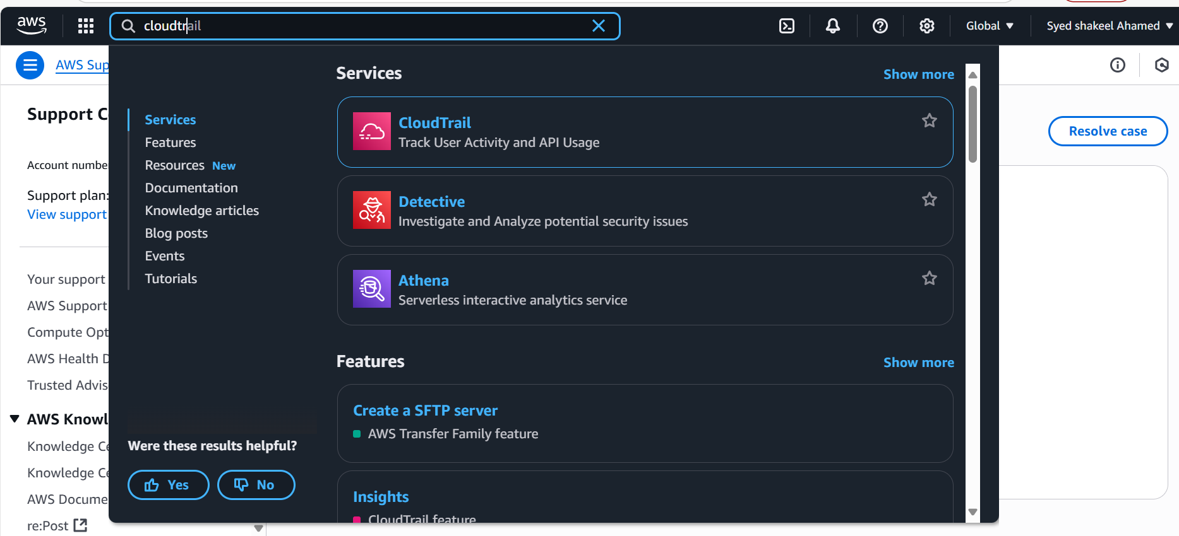

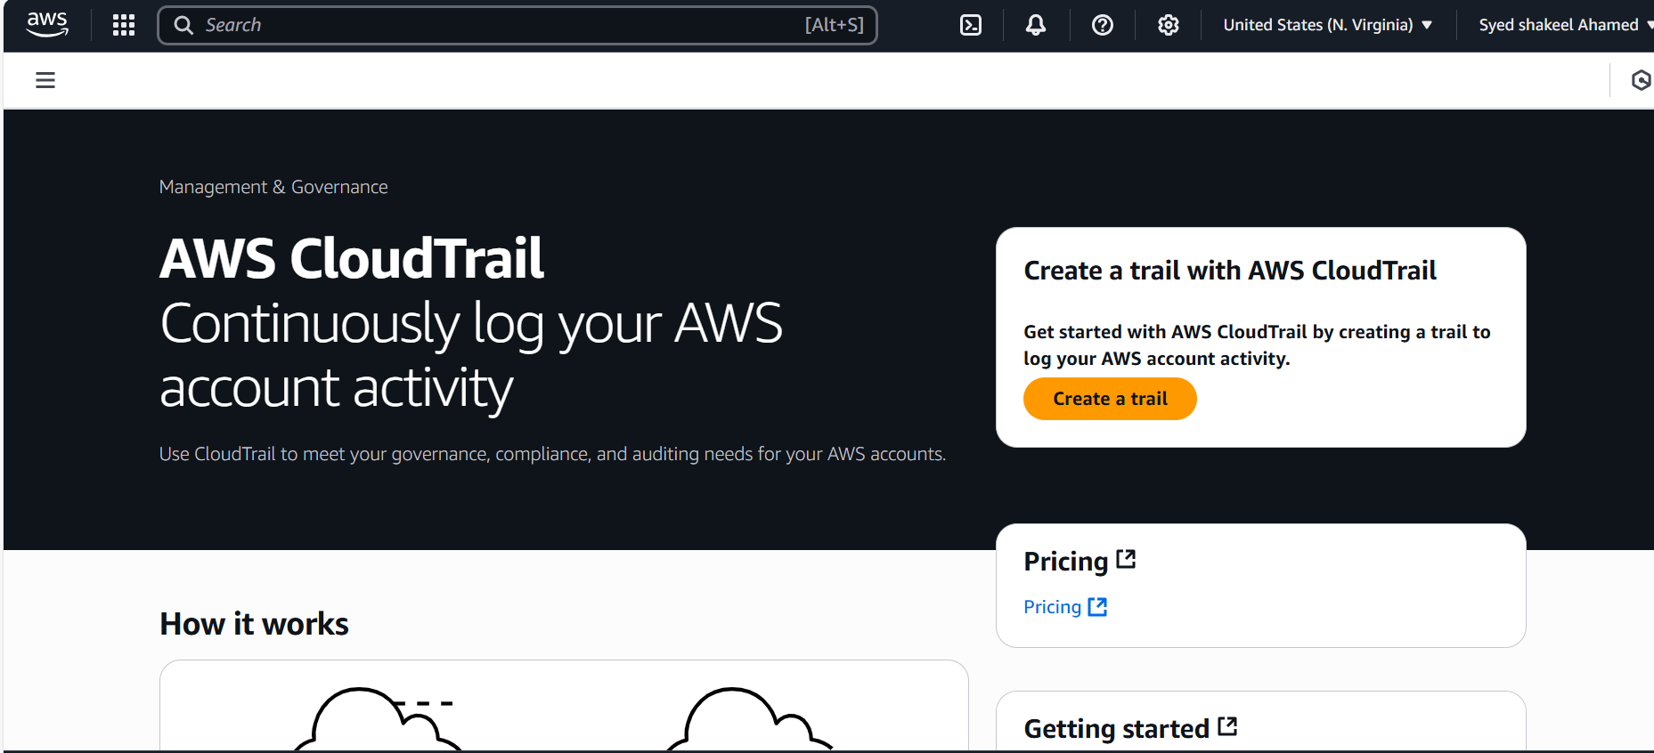

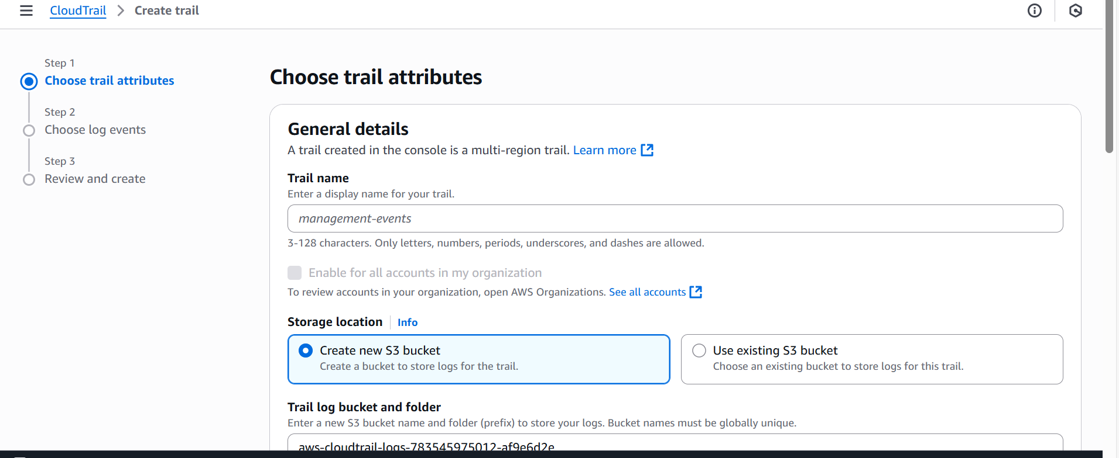

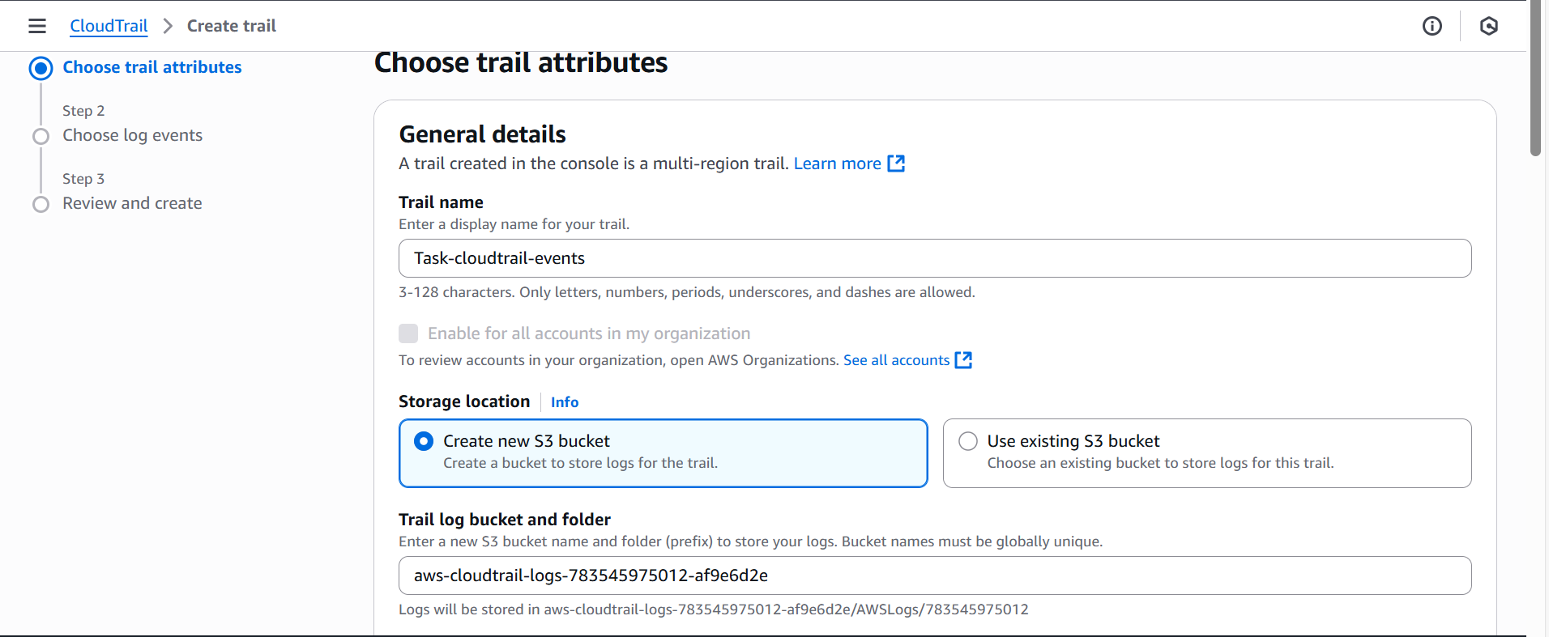

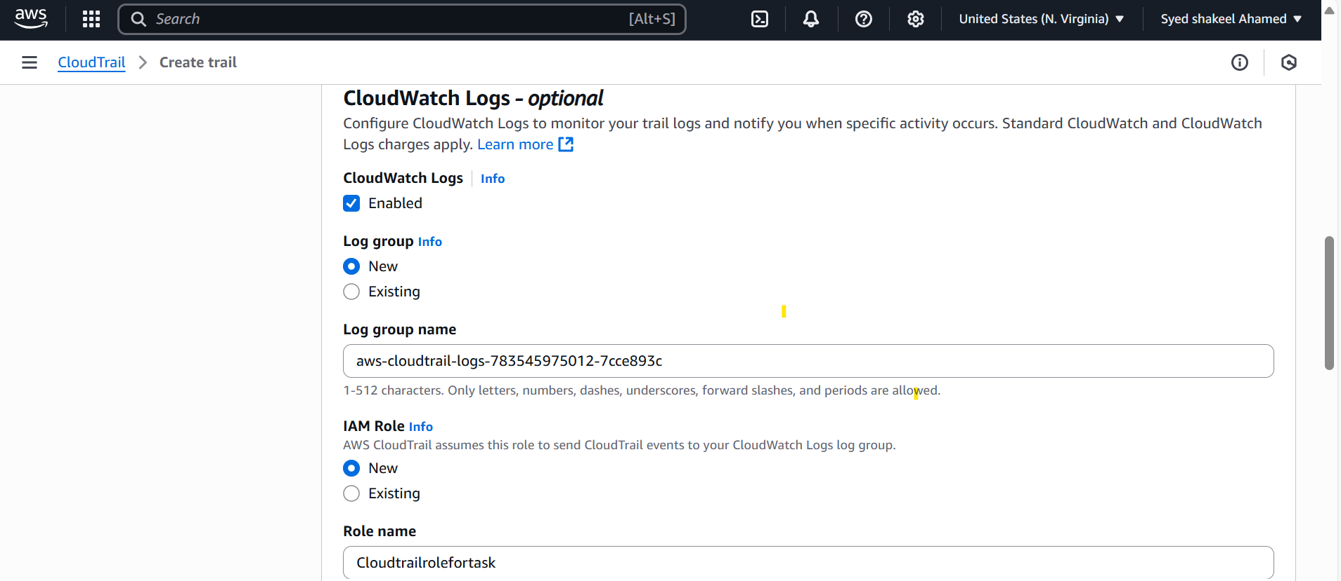

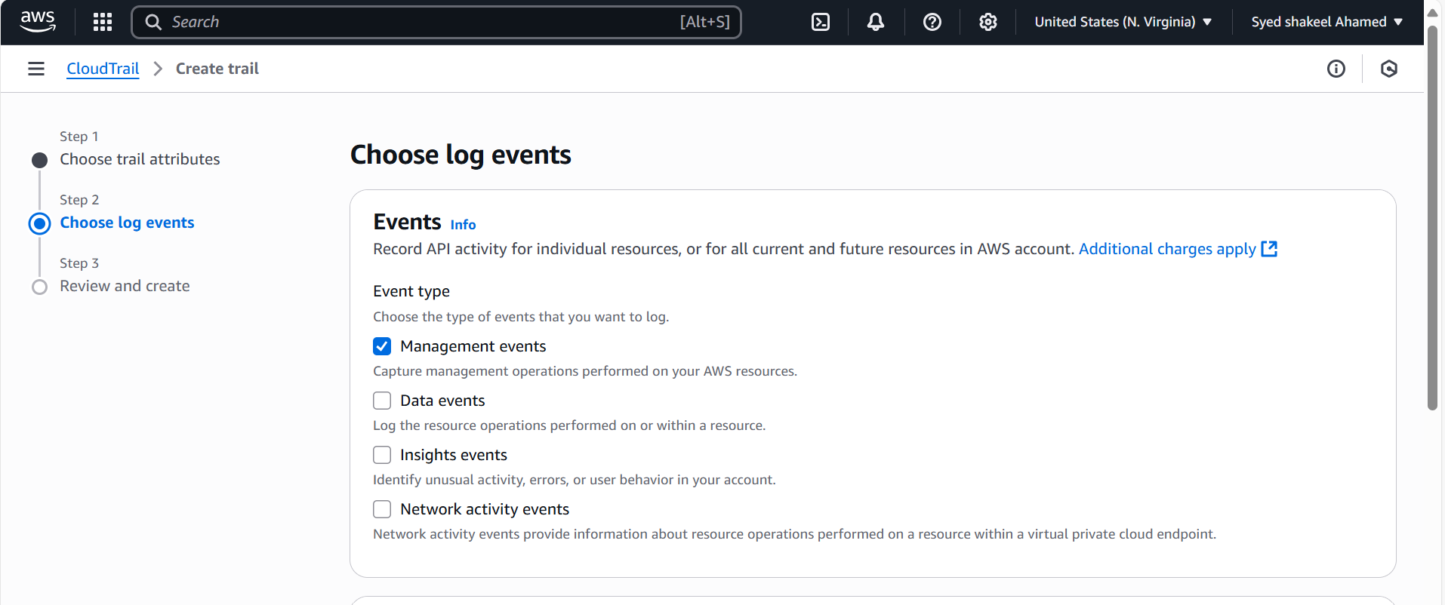

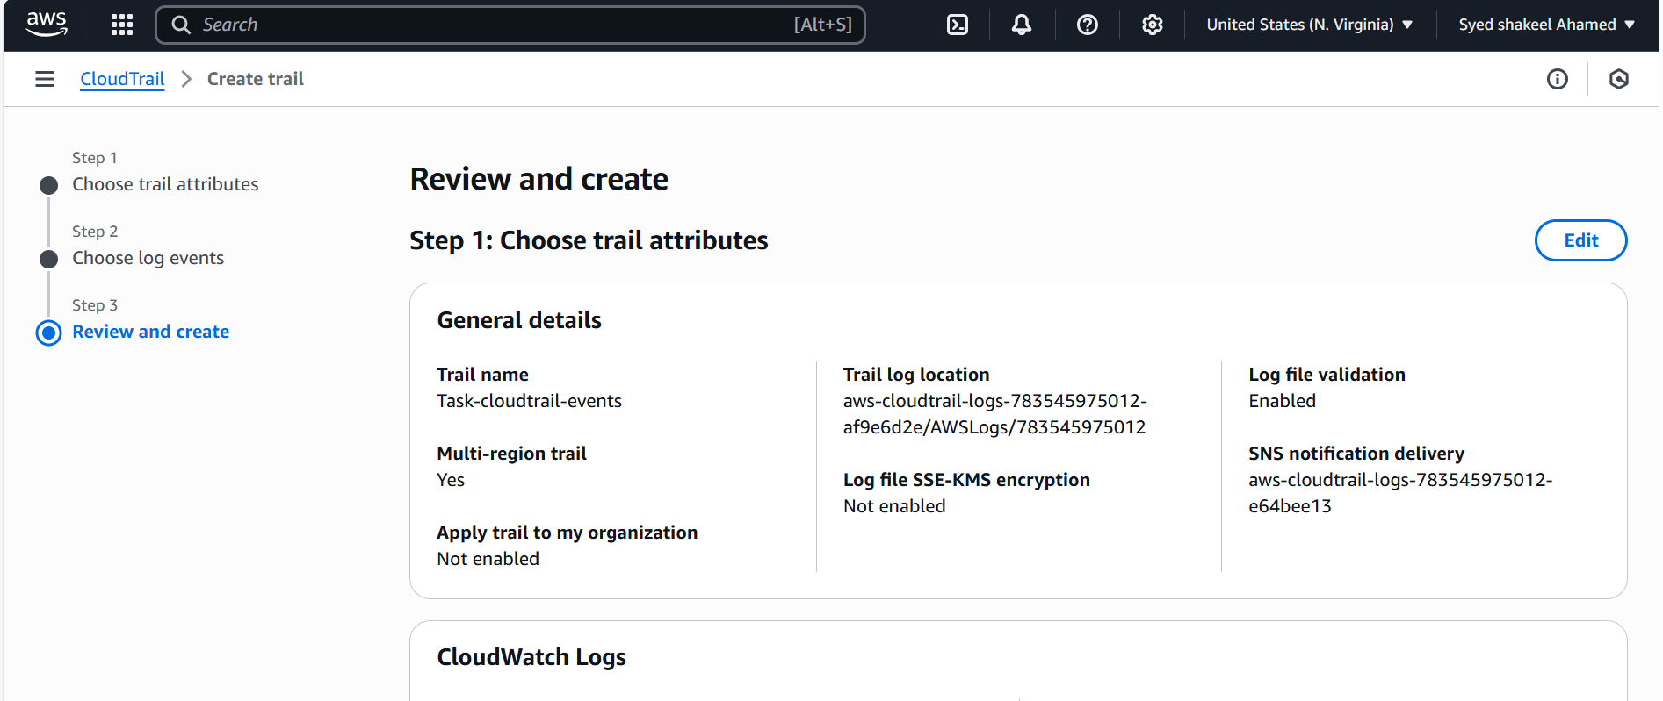

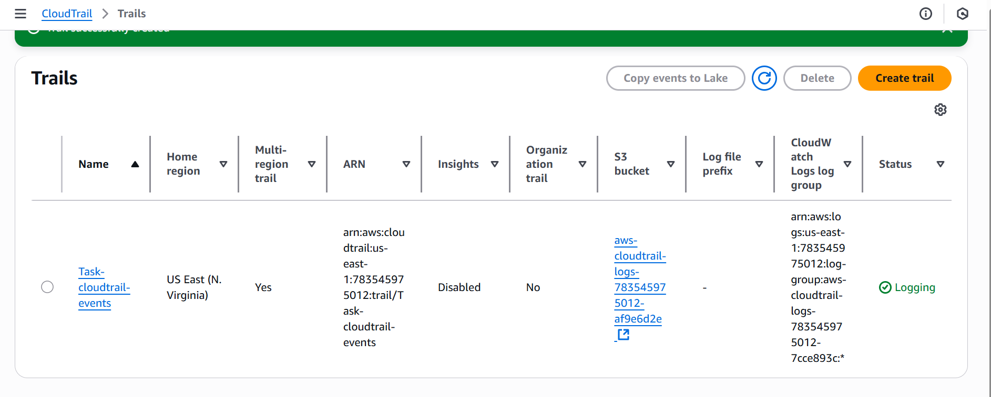

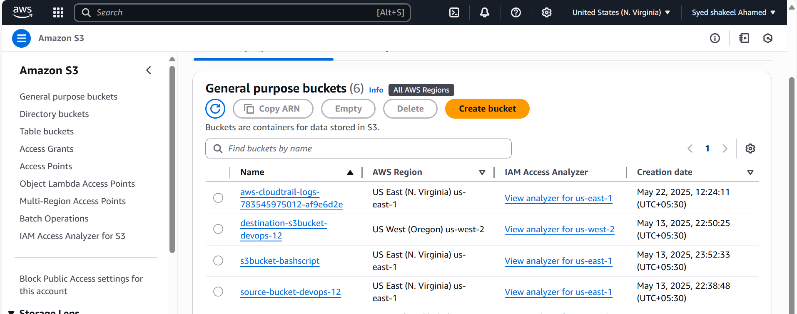

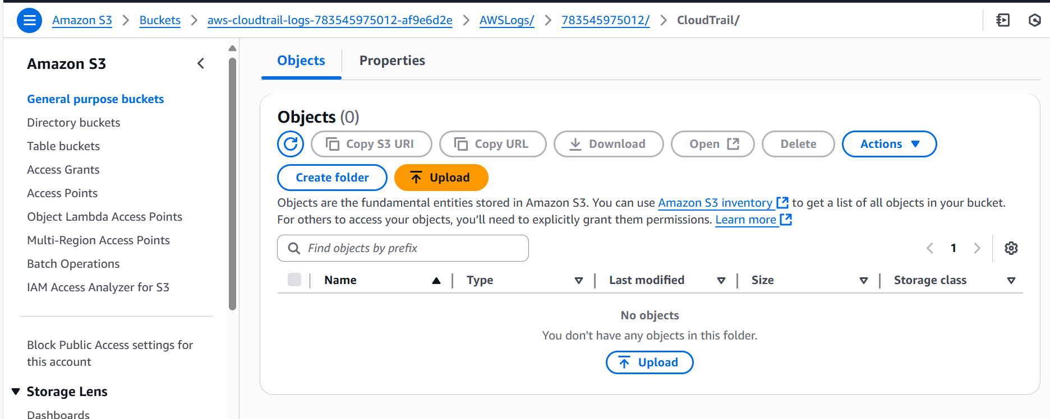

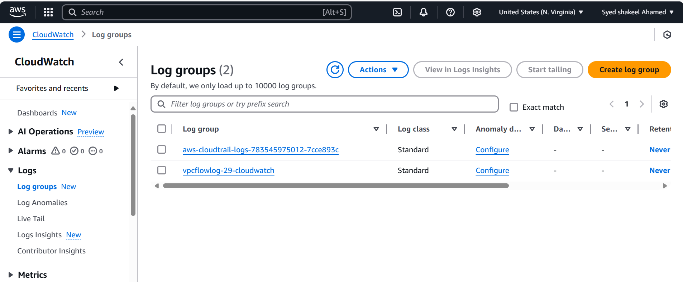

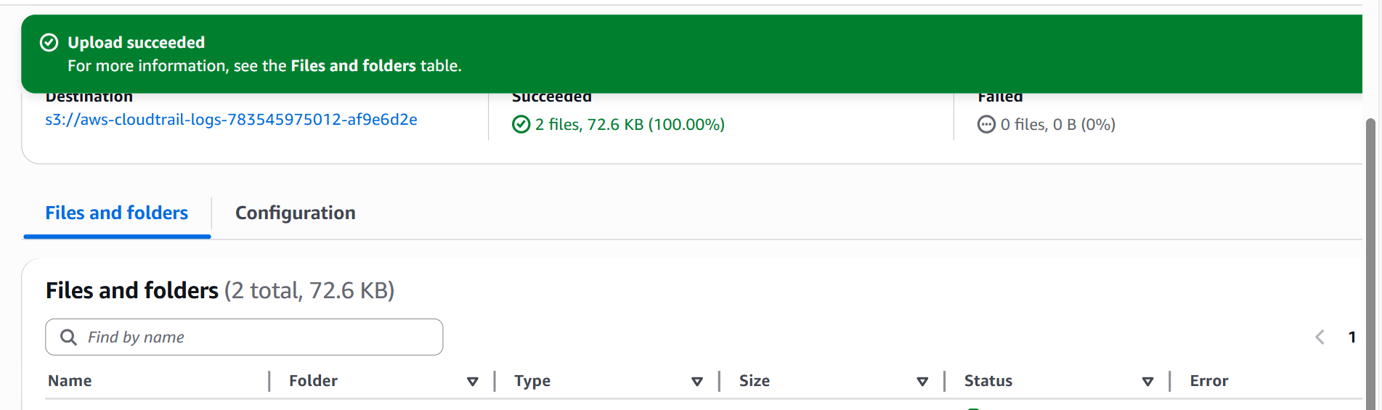

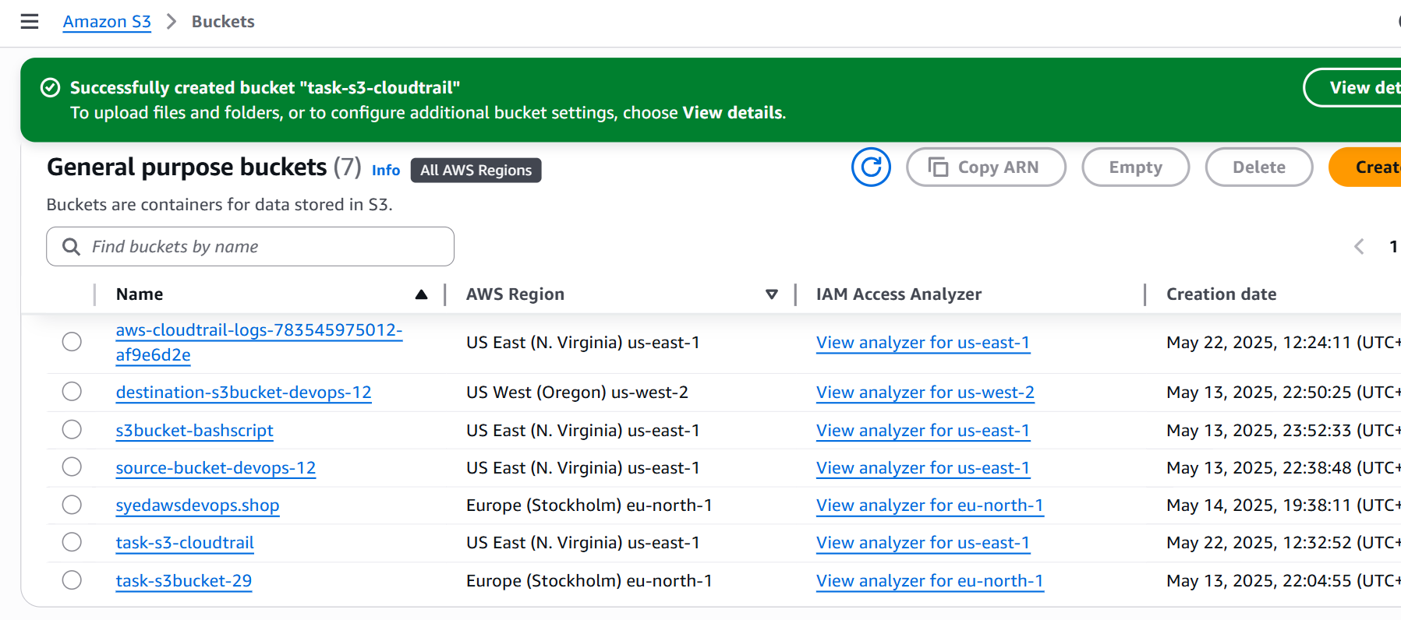

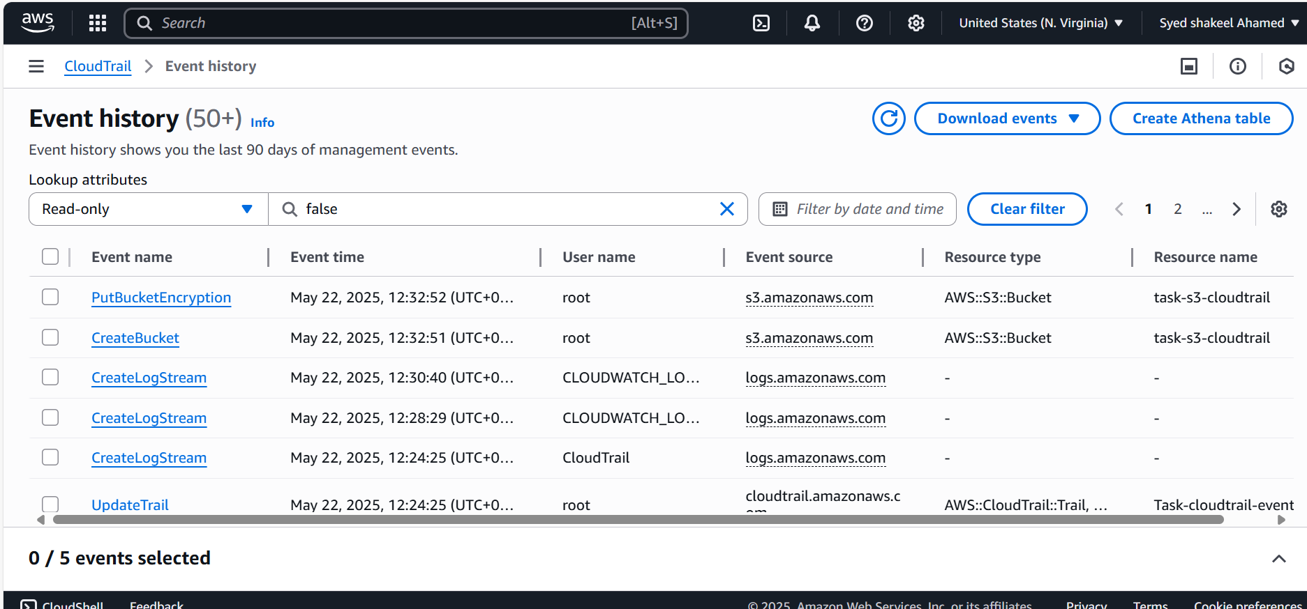

**2) Enable SNS for cloudtrial to send alert on email.**

Enabling Amazon SNS for CloudTrail allows you to receive alerts via email when specific events occur.

Create an SNS Topic

- Open the AWS Management Console → Navigate to Amazon SNS.

- Click Create topic.

- Choose Standard type.

- Name your topic (e.g., Alerts).

- Click Create topic.

Create an SNS Subscription (Email Alert)

- Open the newly created SNS Topic (CloudTrailAlerts).

- Click Create subscription.

- Select Protocol → Email.

- Enter the Email address where alerts will be sent.

- Click Create subscription.

- Check your inbox → Confirm the subscription using the link in the email.

Enable CloudTrail to Publish Events to SNS

- Open the AWS CloudTrail Console.

- Select your Trail (or create a new one).

- Navigate to Event Notification Settings.

- Click Enable SNS Notifications.

- Select the SNS Topic (CloudTrailAlerts).

- Click Save.

Create a CloudWatch Rule to Trigger SNS on Events

- Open the AWS CloudWatch Console → Go to Rules.

- Click Create Rule.

- Choose Event Source → Select CloudTrail.

- Select Specific Events (e.g., DeleteBucket, ConsoleLoginFail, etc.).

- Under Target, select SNS Topic → Choose CloudTrailAlerts.

- Click Create Rule.

5. Test SNS Notifications

- Manually trigger an event (e.g., delete an S3 bucket).

- Check your email for the SNS notification.

Final Verification

✔ Check the SNS Topic for successful message delivery.

✔ Verify emails are received when a triggering CloudTrail event occurs.

✔ Adjust CloudWatch filters to refine alerts.

This setup ensures real-time alerts for critical security events.

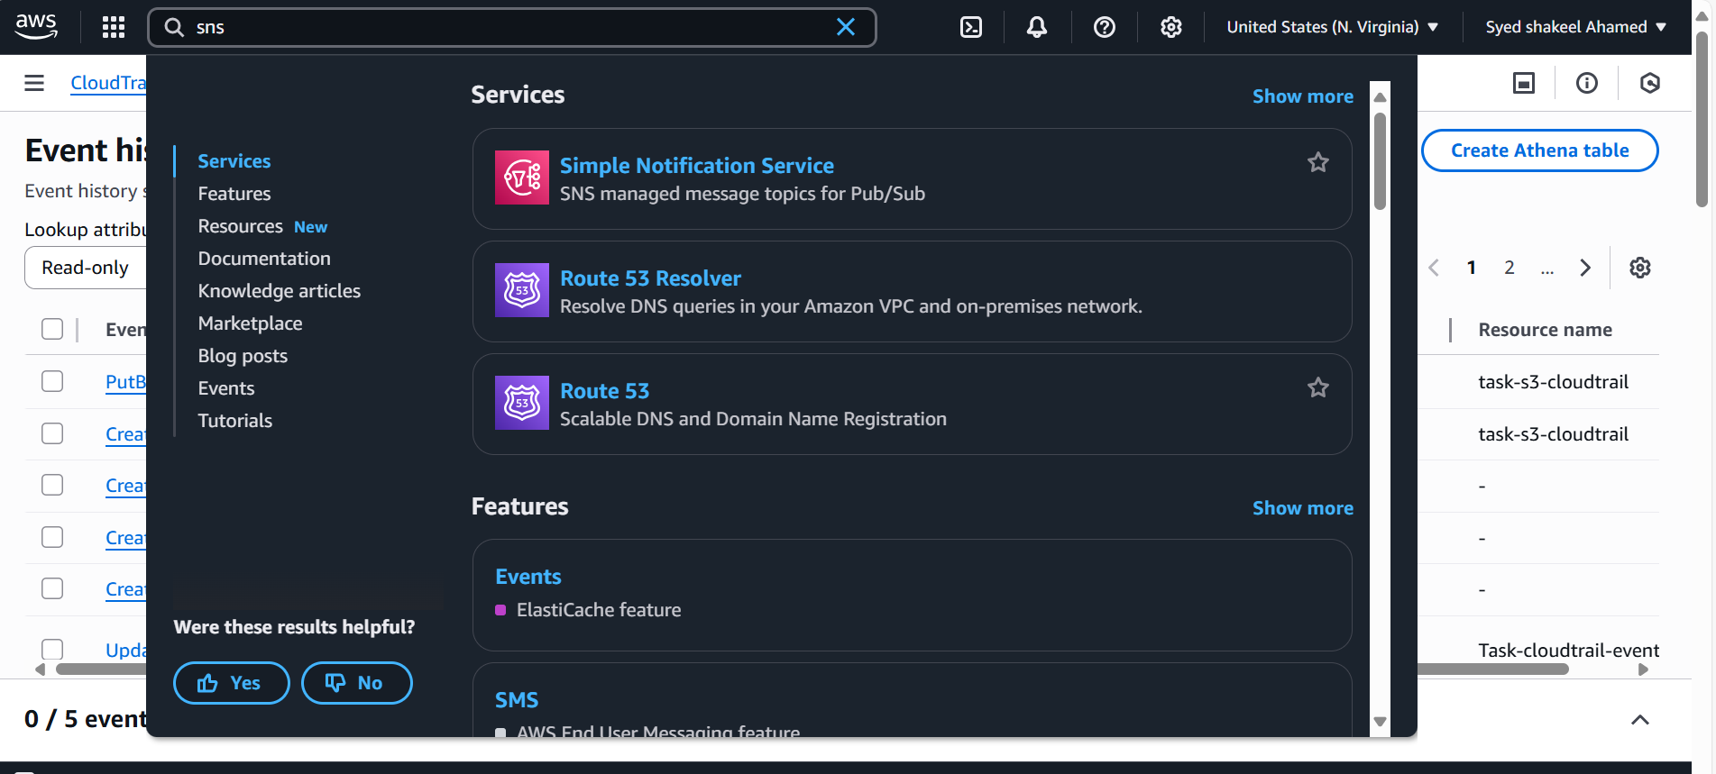

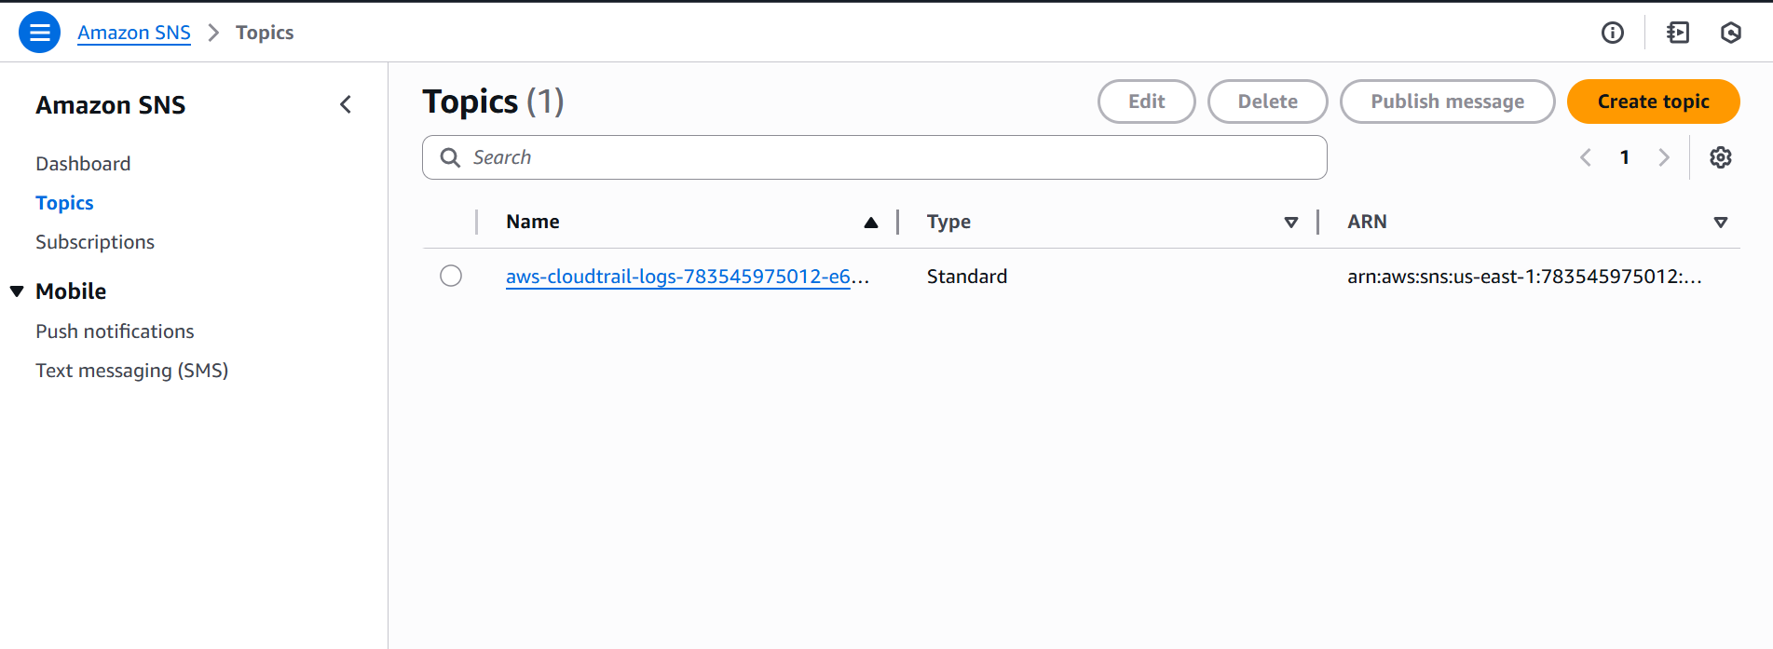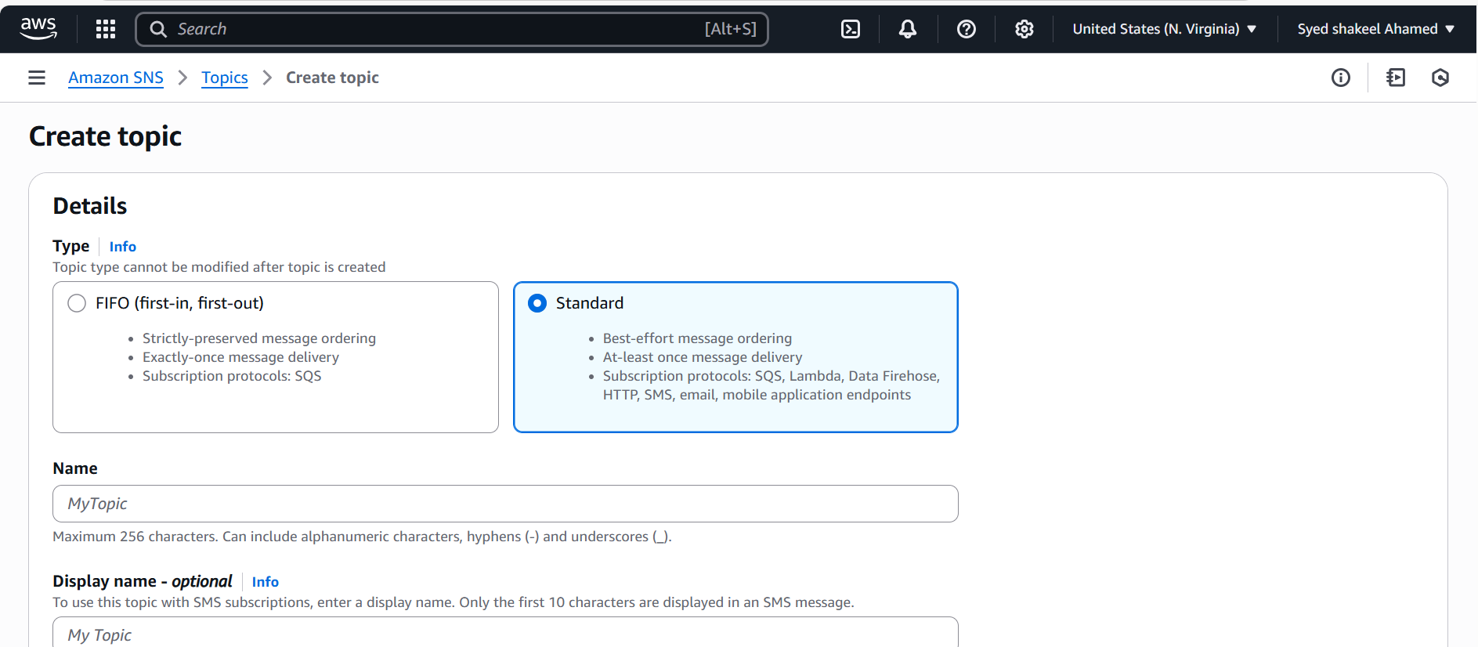

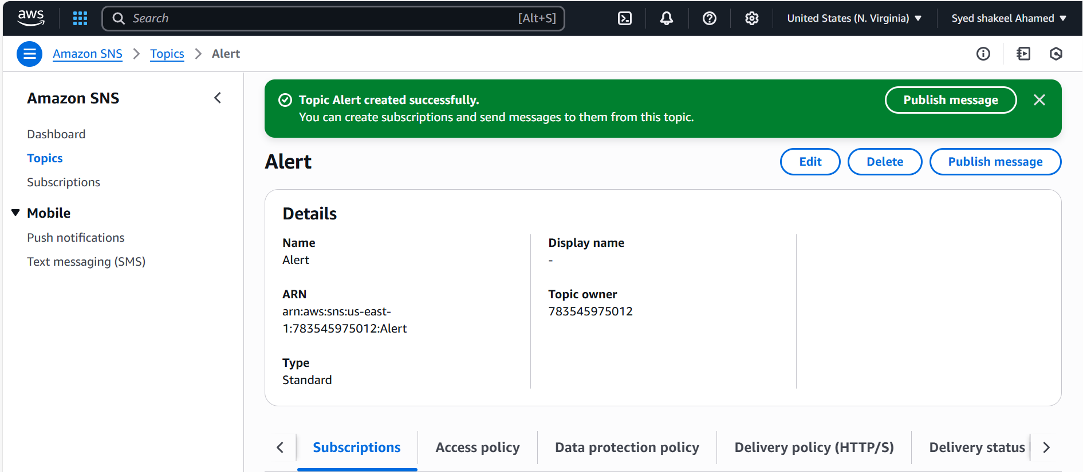

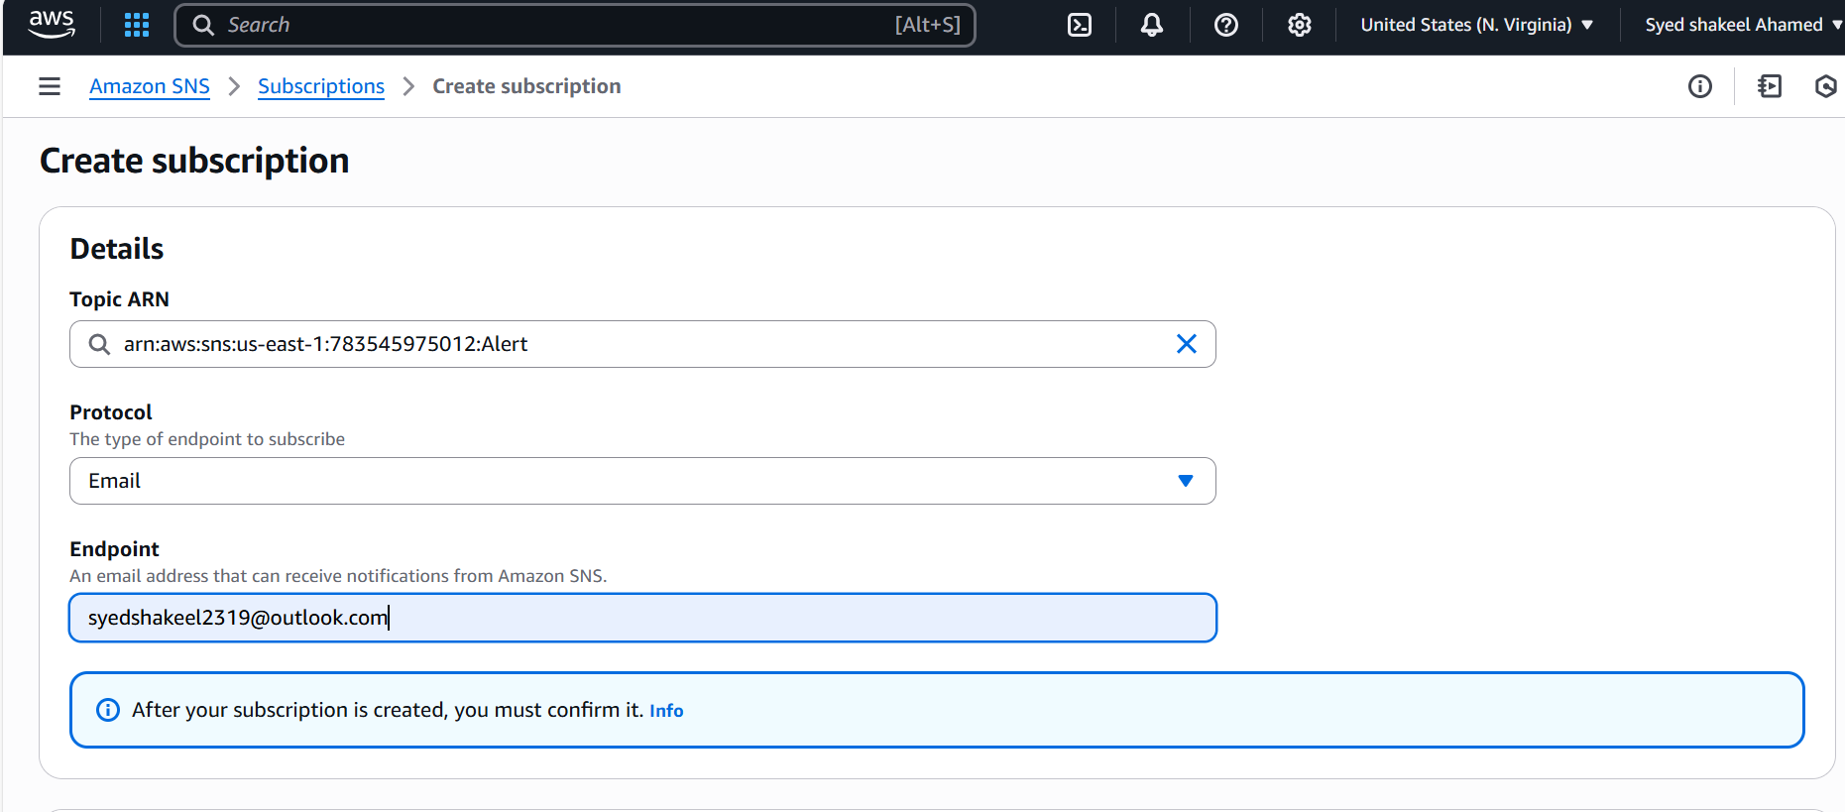

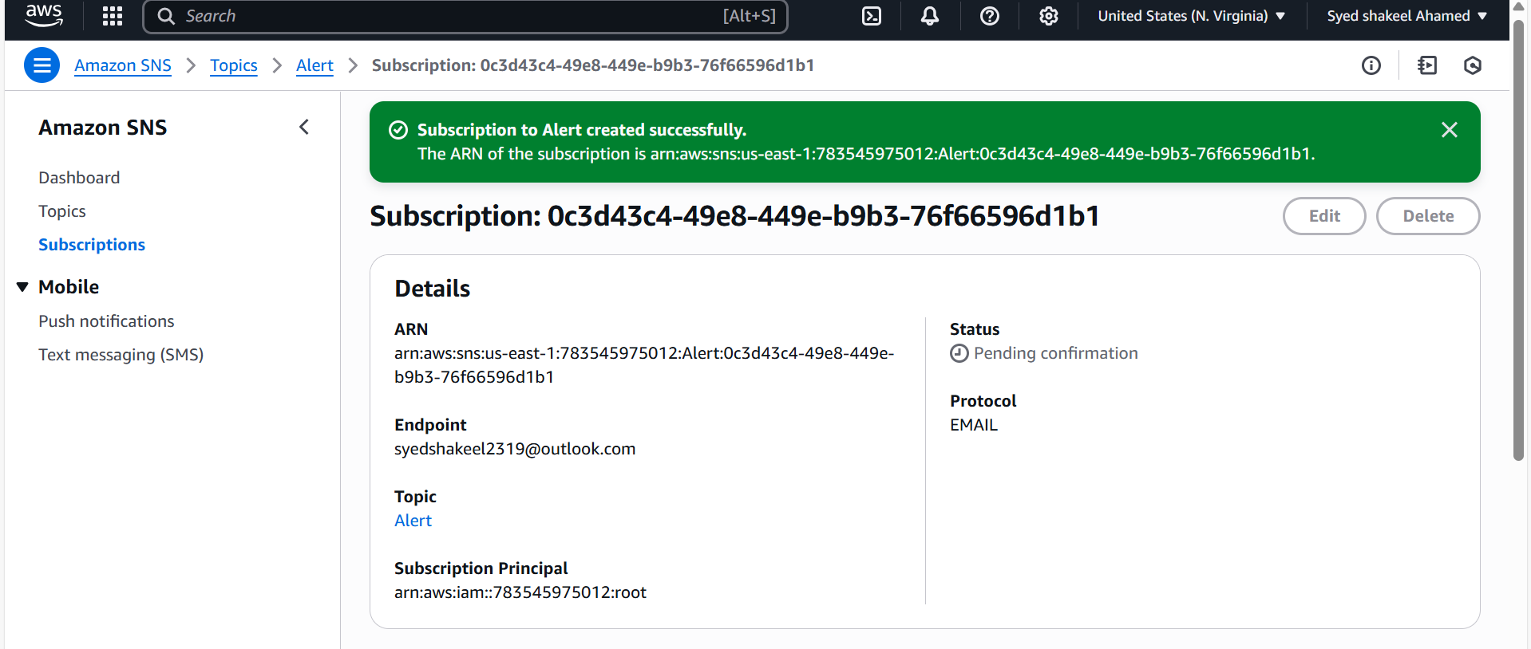

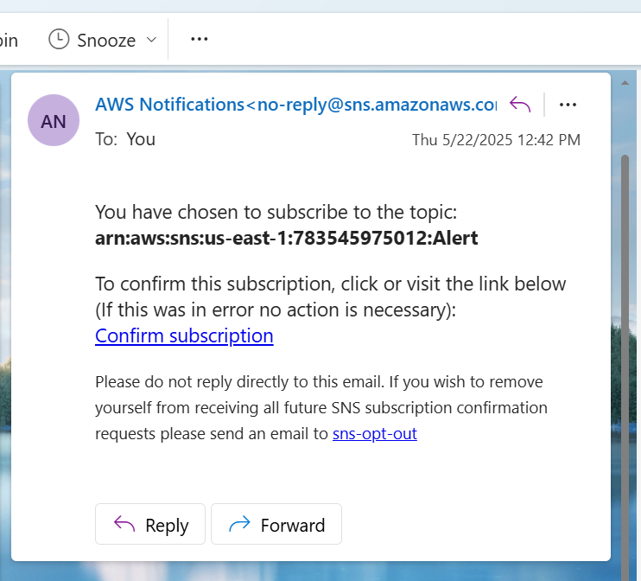

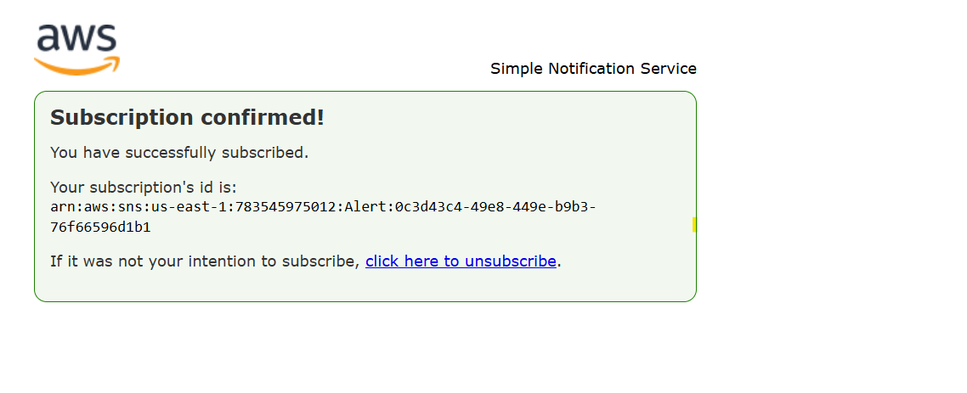

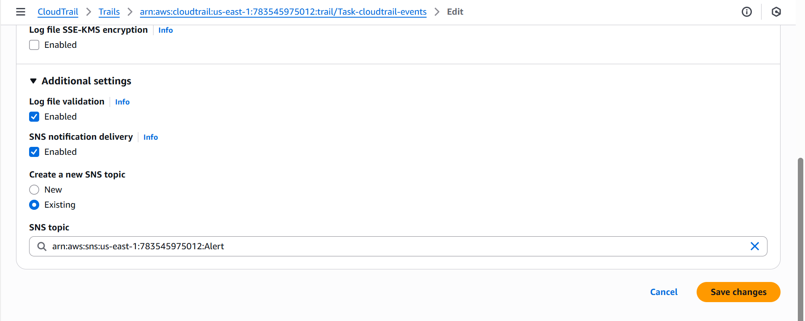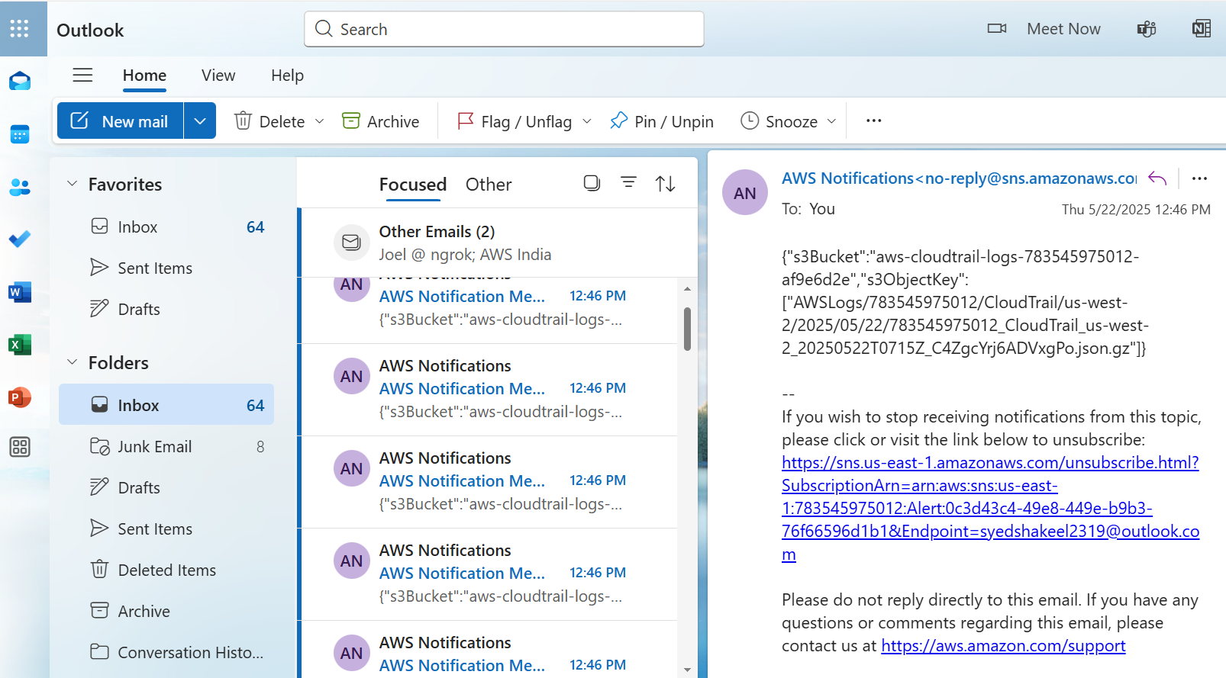

**3) Configure cloud watch monitoring and record the cpu utilization and other metrics of ec2.**

Setting up AWS CloudWatch Monitoring for EC2 allows you to track CPU utilization, disk I/O, network usage, memory, and other metrics in real time.

Enable CloudWatch Metrics for EC2

By default, CloudWatch collects basic EC2 metrics every 5 minutes. For detailed monitoring (every 1 minute), enable it manually.

Steps to Enable Detailed Monitoring

- Open AWS Console → Navigate to EC2.

- Select your EC2 instance.

- Click Modify Instance.

- Under Monitoring, check Enable Detailed Monitoring.

- Click Save.

2. View EC2 Metrics in CloudWatch

- Open AWS Console → Navigate to CloudWatch.

- Click Metrics → Select EC2.

- Choose your Instance ID to view:

- CPUUtilization

- NetworkIn and NetworkOut

- DiskReadOps and DiskWriteOps

- StatusCheckFailed (for instance health)

3. Set Up CloudWatch Alarms

To receive alerts when CPU utilization exceeds a threshold.

Create an Alarm

- Open CloudWatch → Navigate to Alarms.

- Click Create Alarm.

- Choose EC2 Metrics → Select CPUUtilization.

- Set Threshold Condition, e.g., "Greater than 70%"

- Choose Action → Send Notification via SNS.

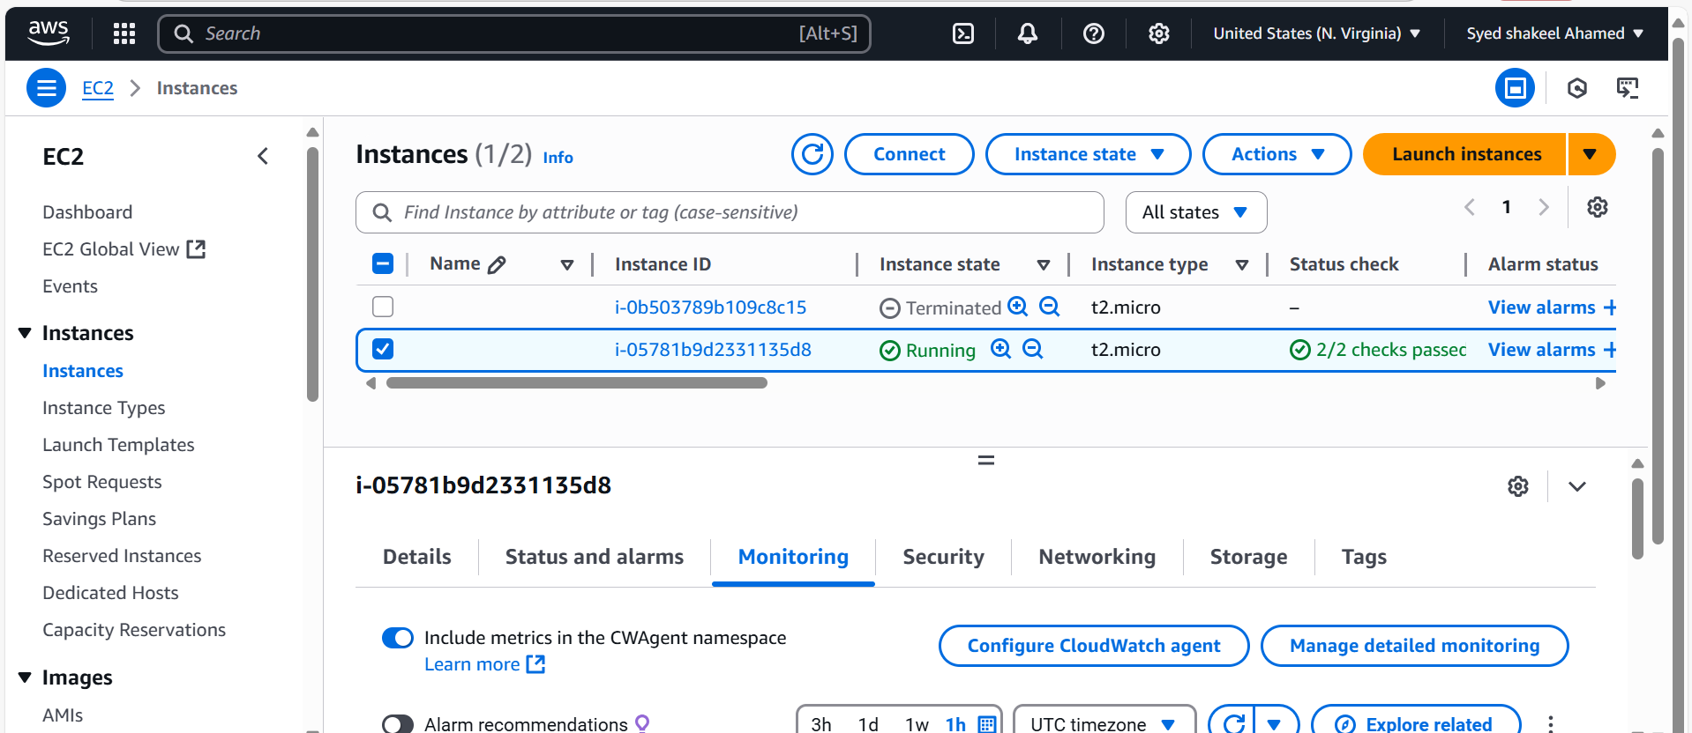

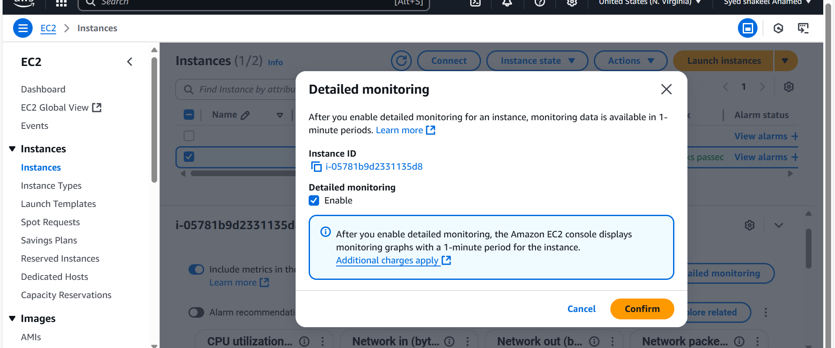

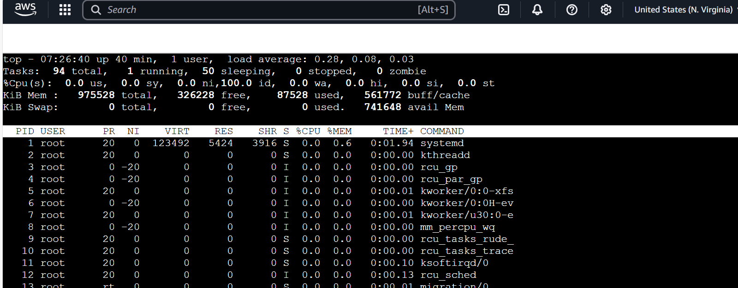

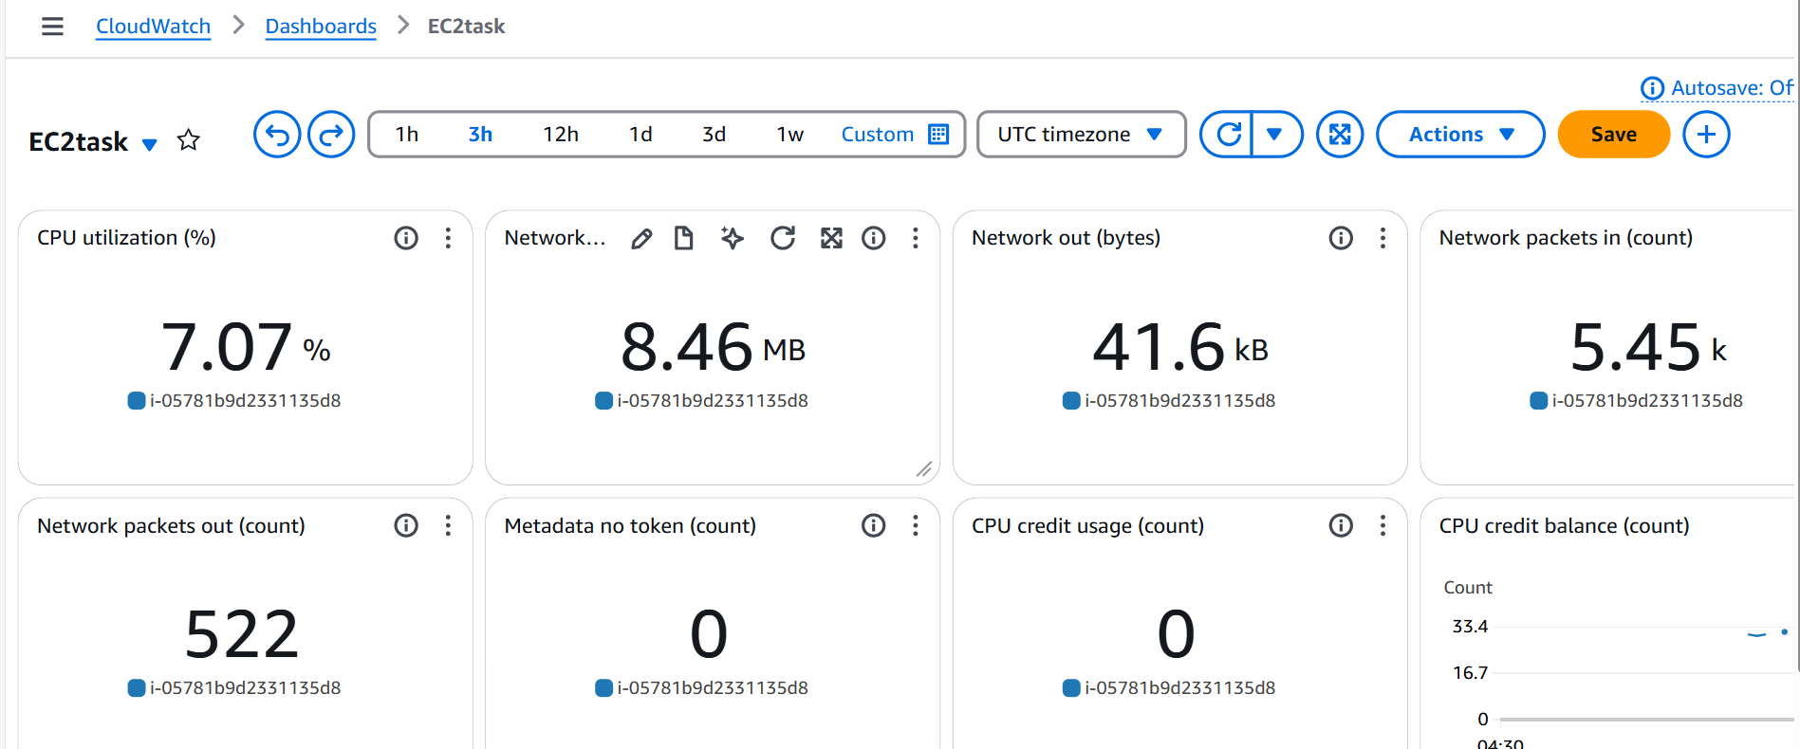

**4) Create one alarm to send alert to email if the cpu utilization is more than 70 percent.**

Create an Amazon SNS Topic

- Open the AWS Console → Go to SNS.

- Click Create topic.

- Select Standard type.

- Enter a Topic name (e.g., CPU-utilization)

- Click Create topic.

Step 2: Subscribe to SNS (Email Notification)

- Open the newly created SNS Topic (CPUAlert).

- Click Create subscription.

- Select Protocol → Email.

- Enter the Email address for alerts.

- Click Create subscription.

- Check your inbox → Confirm the subscription via email.

Step 3: Create a CloudWatch Alarm for CPU Utilization

- Open the AWS Console → Navigate to CloudWatch.

- Go to Alarms → Click Create Alarm.

- Click Select metric.

- Choose EC2 Metrics → Select CPUUtilization.

- Click Per-Instance Metrics → Choose your Instance ID.

Step 4: Set Alarm Conditions

- Set Statistic → Average.

- Set Period → 5 minutes (or preferred interval).

- Choose Threshold Type → Static.

- Select Condition → Greater than 70%.

Step 5: Add SNS Notification to Alarm

- Under Actions, click Send notification to an SNS topic.

- Choose your SNS topic (HighCPUAlert).

- Click Next.

Step 6: Configure Alarm Name & Finish

- Name the alarm (e.g., EC2-High-CPU).

- Add a description (optional).

- Click Create Alarm.

Step 7: Test the Alarm

- Generate high CPU usage:

yes > /dev/null &

- Check if the CloudWatch alarm triggers an email.

- Stop high CPU usage:

killall yes

Final Verification

✔ Ensure alarm triggers notifications on high CPU usage.

✔ Adjust threshold if needed.

✔ View metrics in CloudWatch Dashboard.

This setup ensures real-time CPU monitoring and alerts.

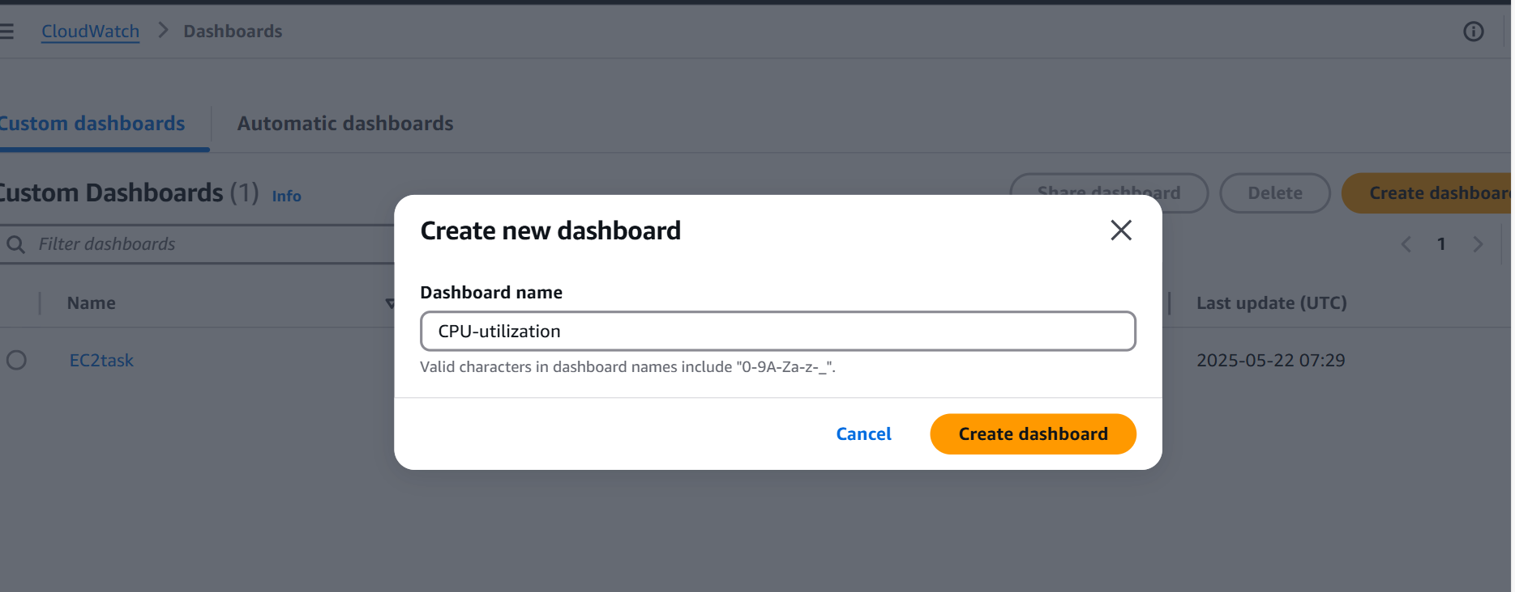

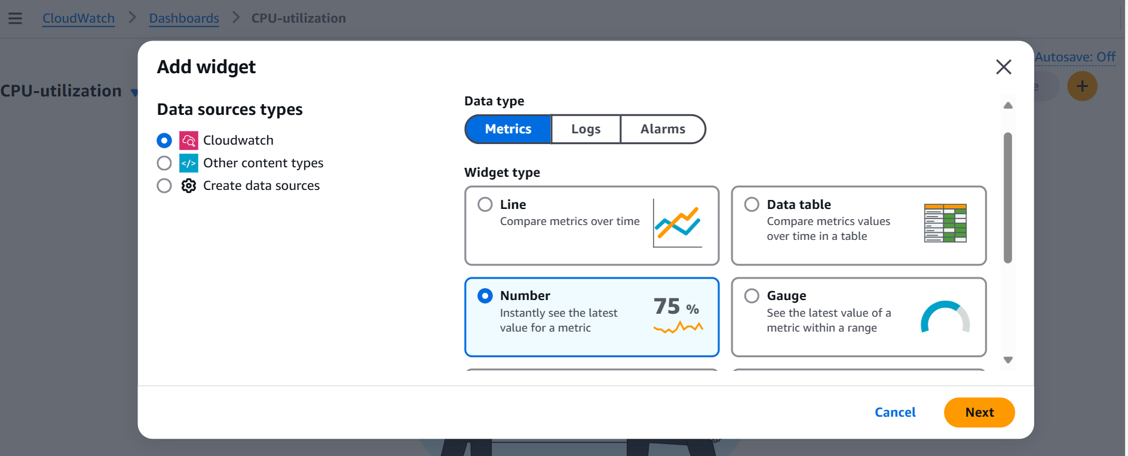

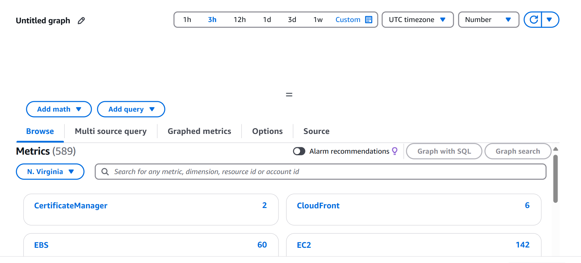

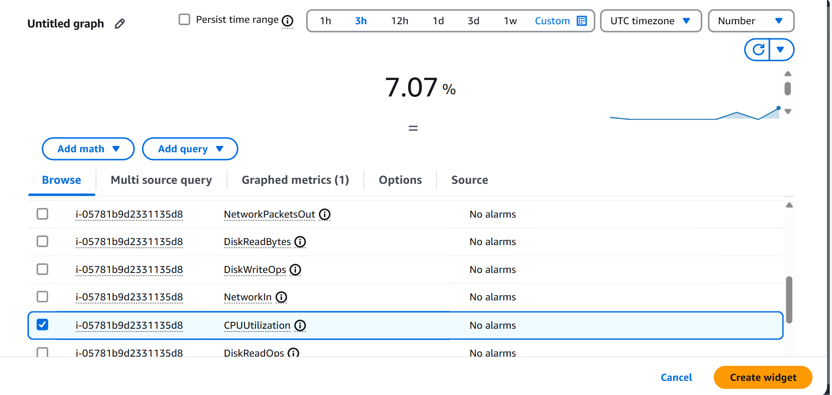

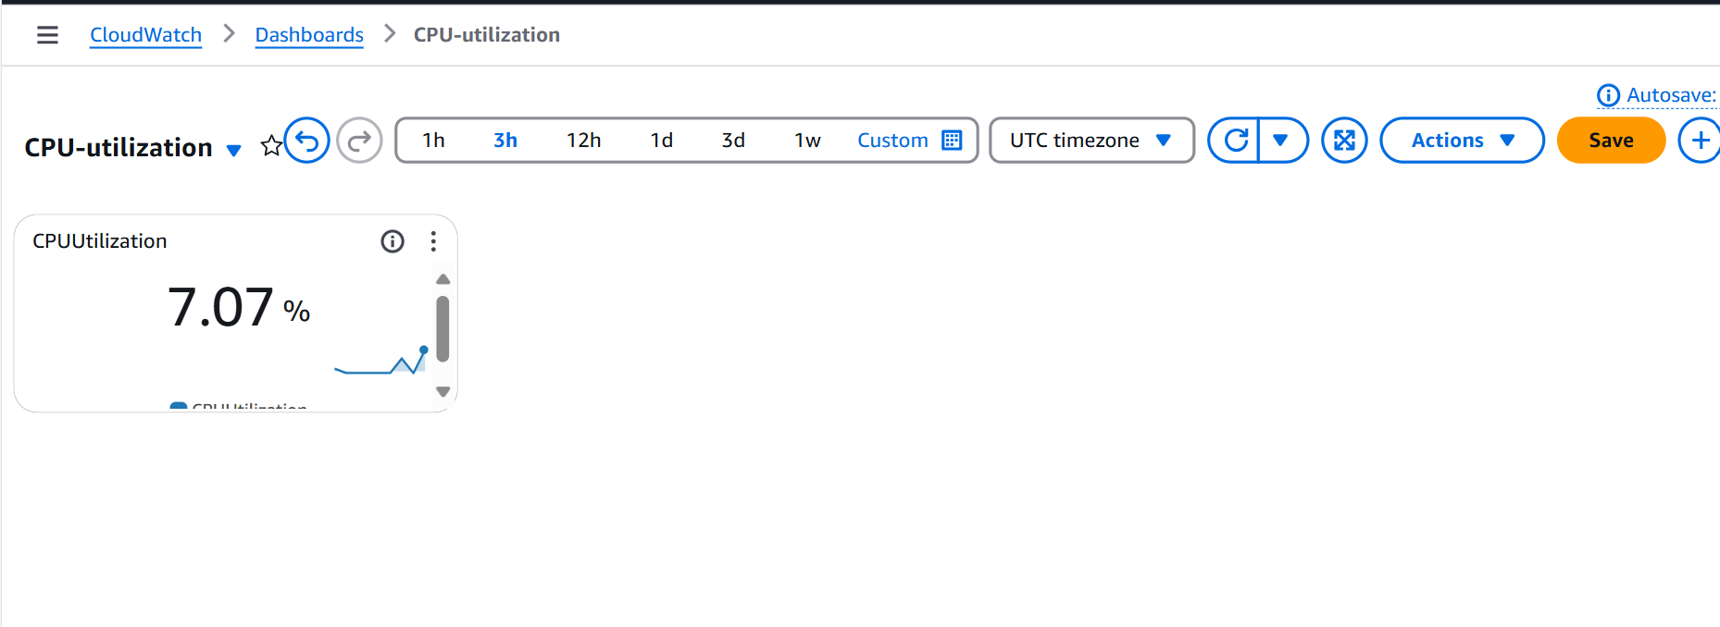

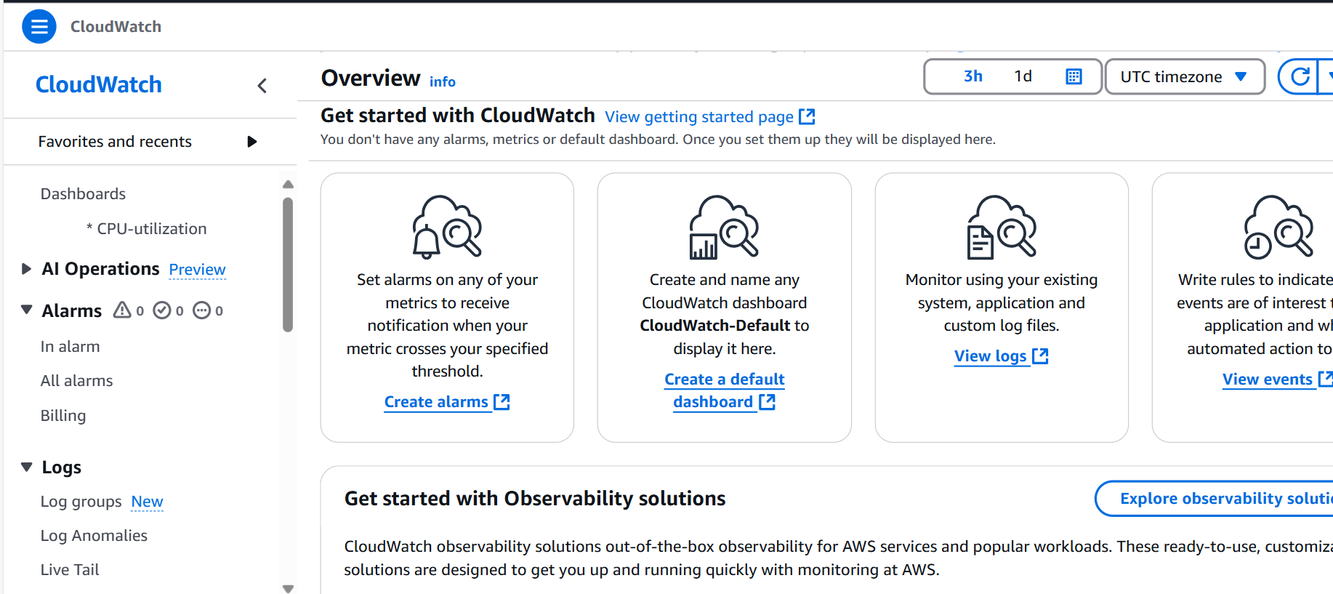

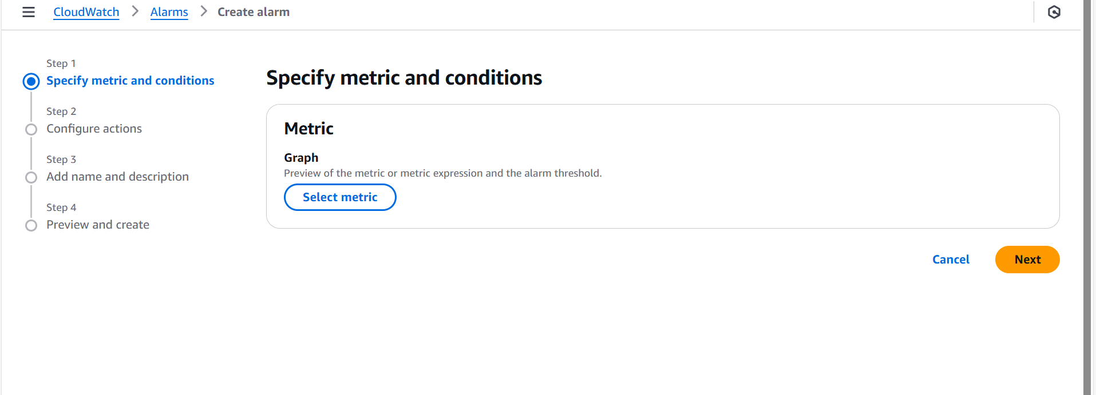

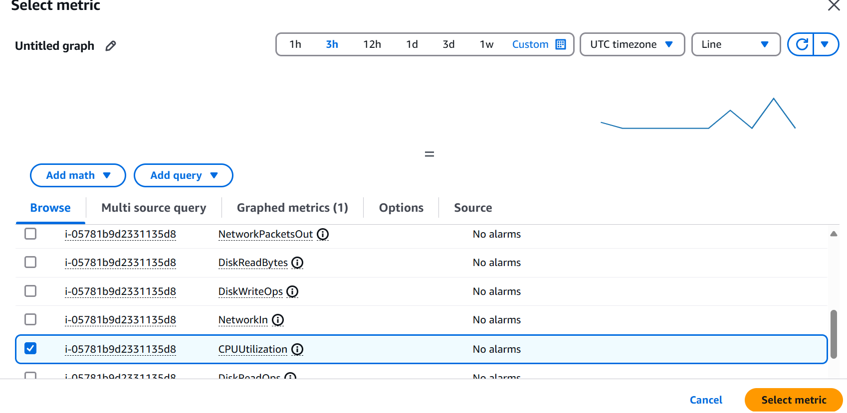

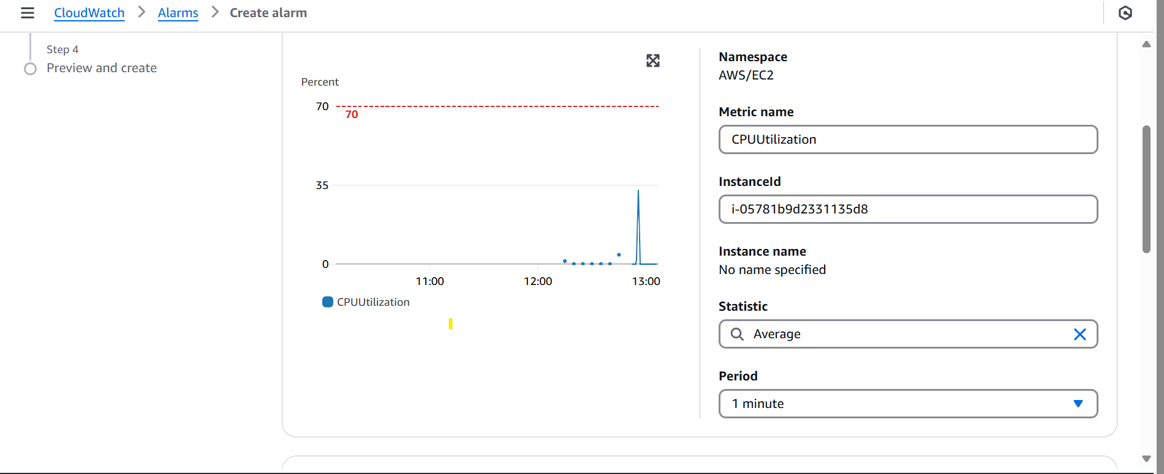

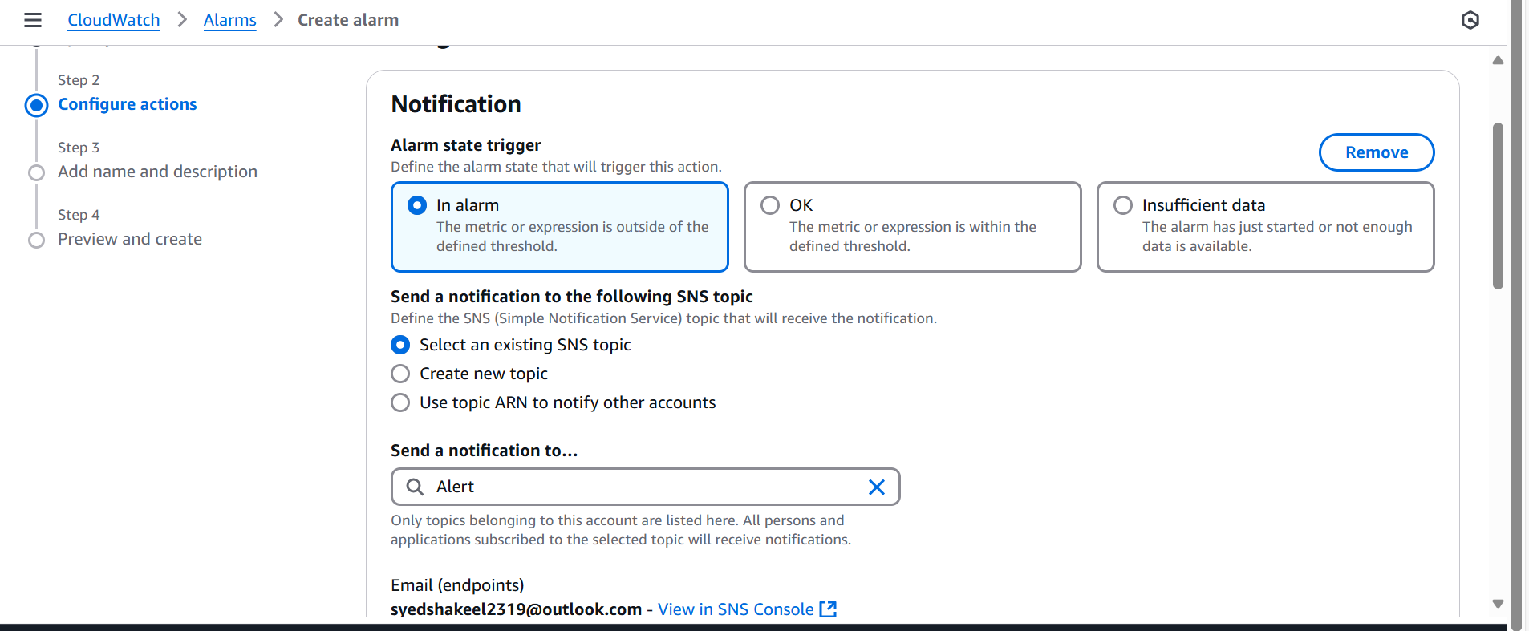

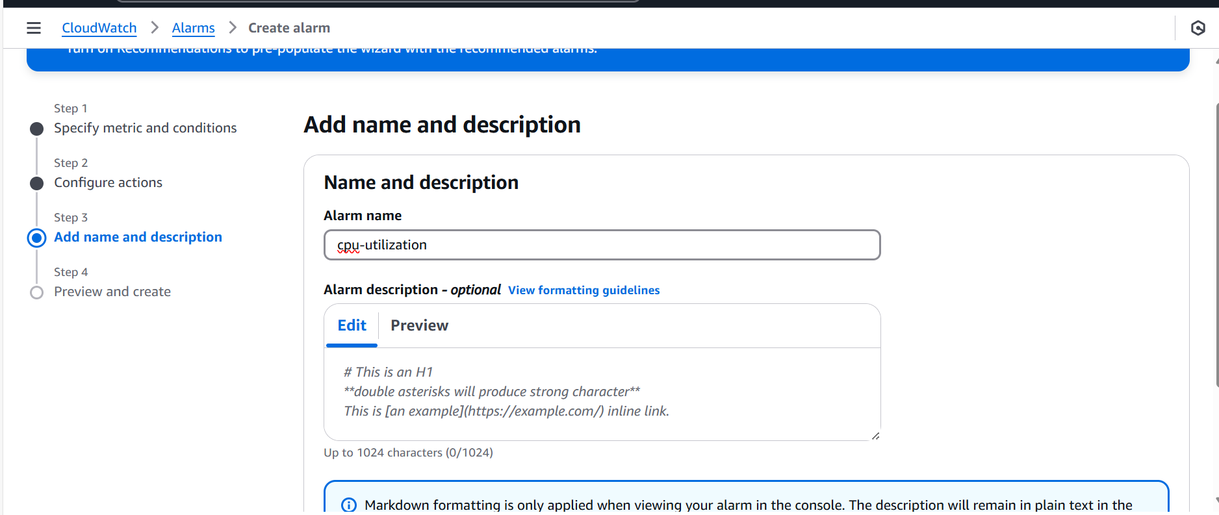

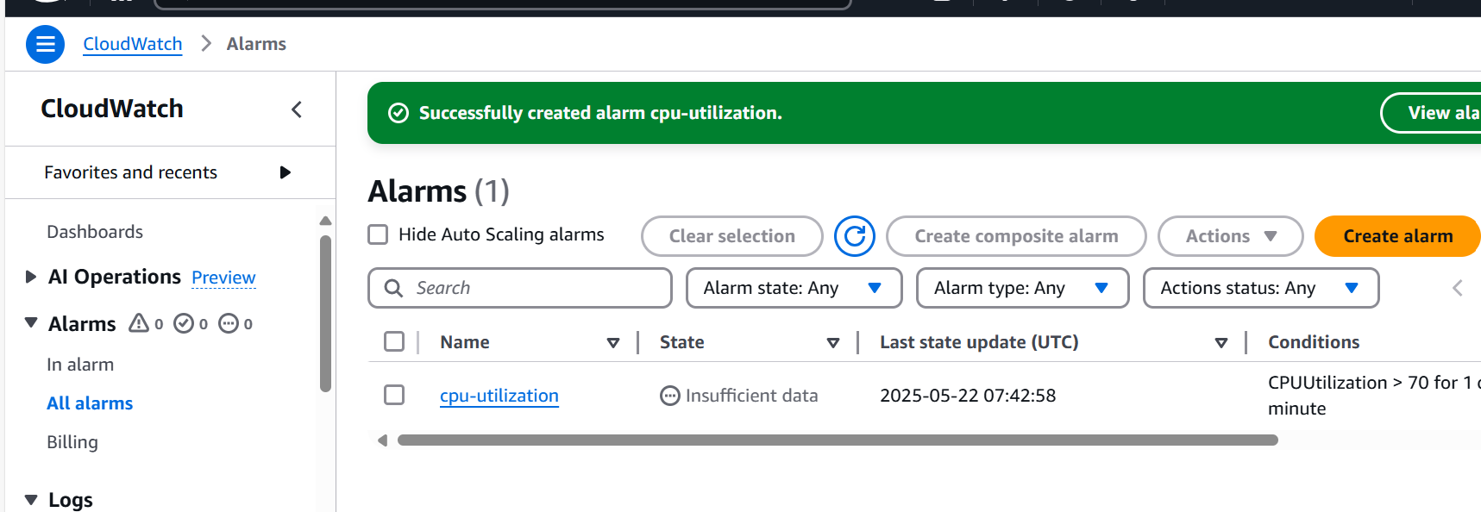

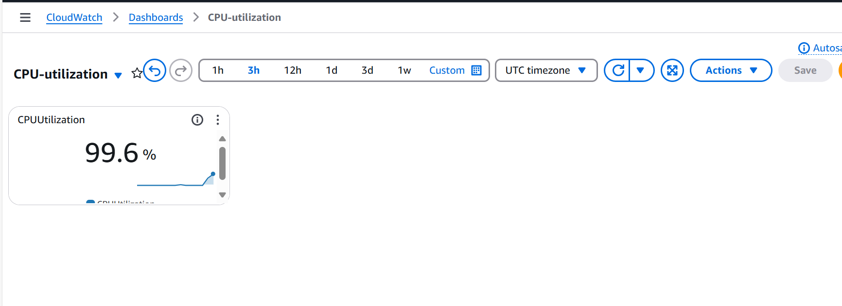

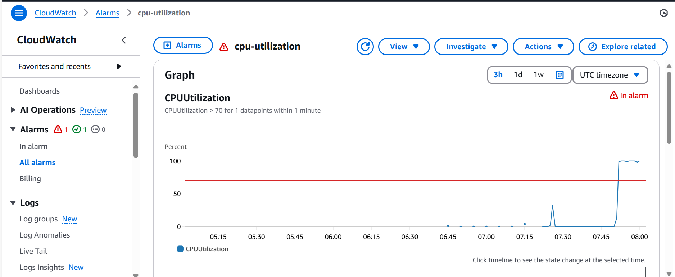

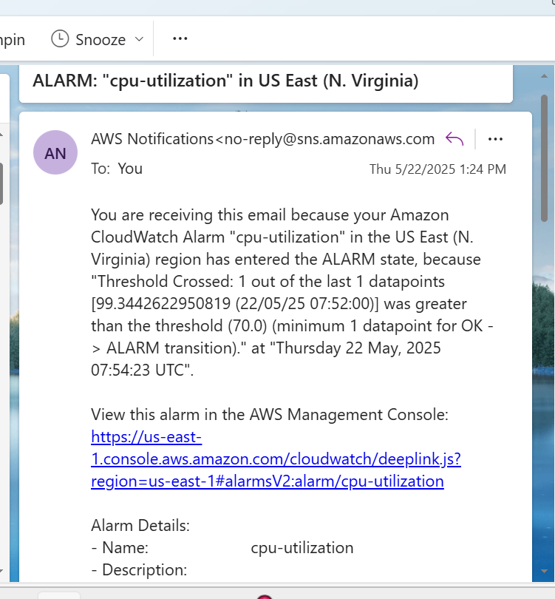

**5) Create Dashboard and monitor tomcat service whether it is running or not and send the alert.**

Monitor a tomcat service and send the meric to Cloudwatch is customizing our own metrics

First Go to AWS management console and Install and launch one EC2 Connect the EC2 to console and Switch to root user

Now Install Java as it is prerequisite to run our tomcat

After java is installed , download the Apache-tomcat version 9

Extract the tar file and install the tomcat using ./startup.sh

Once the tomcat service is started and access the browser using Public_ip:8080

Next now execute one bash script to push the metrics to Cloudwatch Dashboard for tomcat service

Execute the bash script file and by changing the permission chmod 777 filename

Configure the AWS CLI for aws configure using ACCESS key and secret key credentials

Now execute the bash script file to push the metric to cloudwatch dashboard

Check the CloudWatch dashboard for metric tomcat service running Create widget using instance id

Configure a cronjob to check for every 1 minute 1 * * * * /root/tomcatmonitoring.bash

Create alarms for tomcat metric OK for greater than 0 In alarm for less than 1 In while creating alarms , set SNS for email address alert

So whenever tomcat service is running/stopped alert will be sent to email address and verify in Cloudwatch dashboard.

This is how we can customize our own metrics for tomcat service.

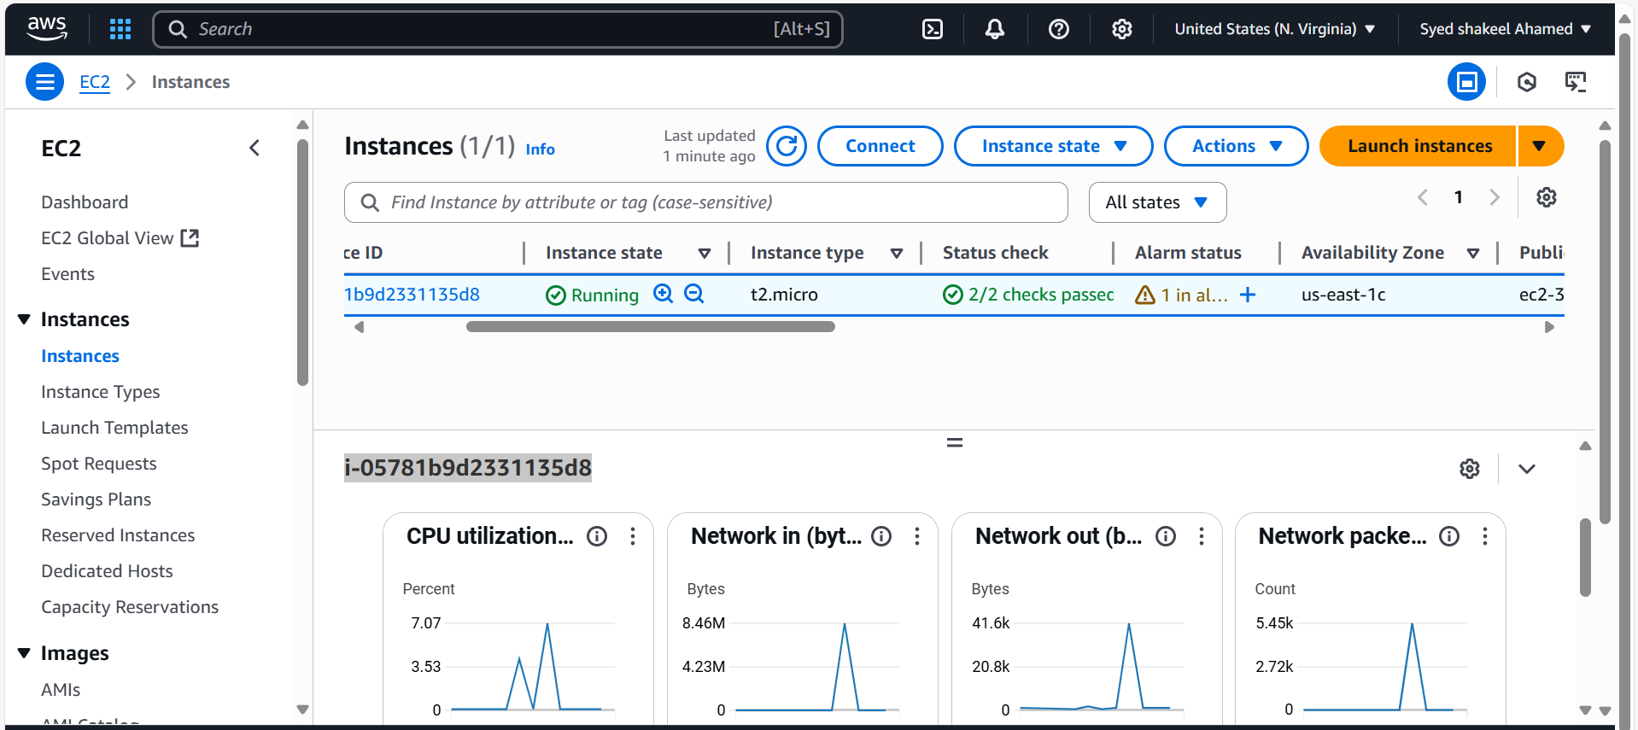

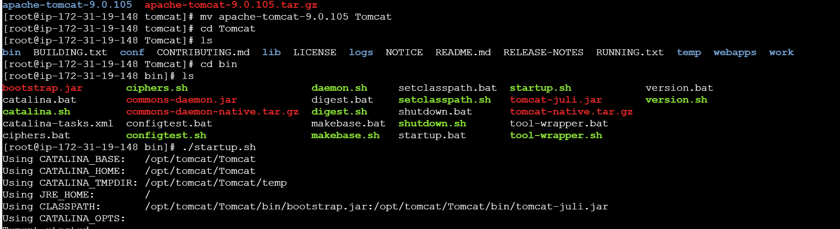

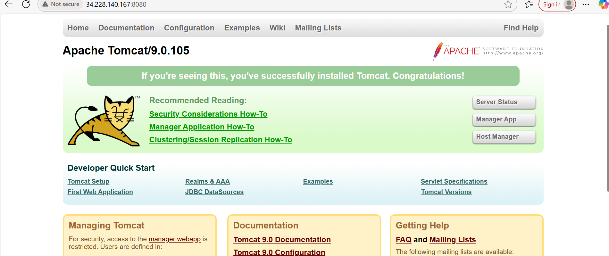

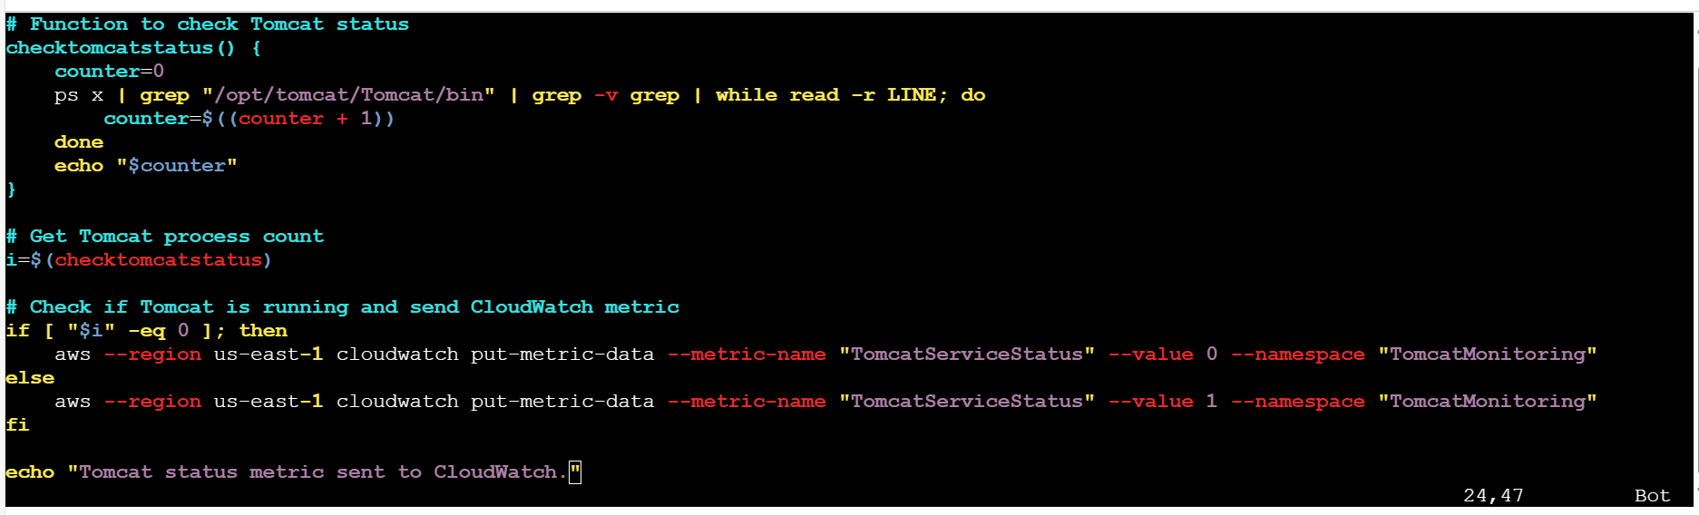

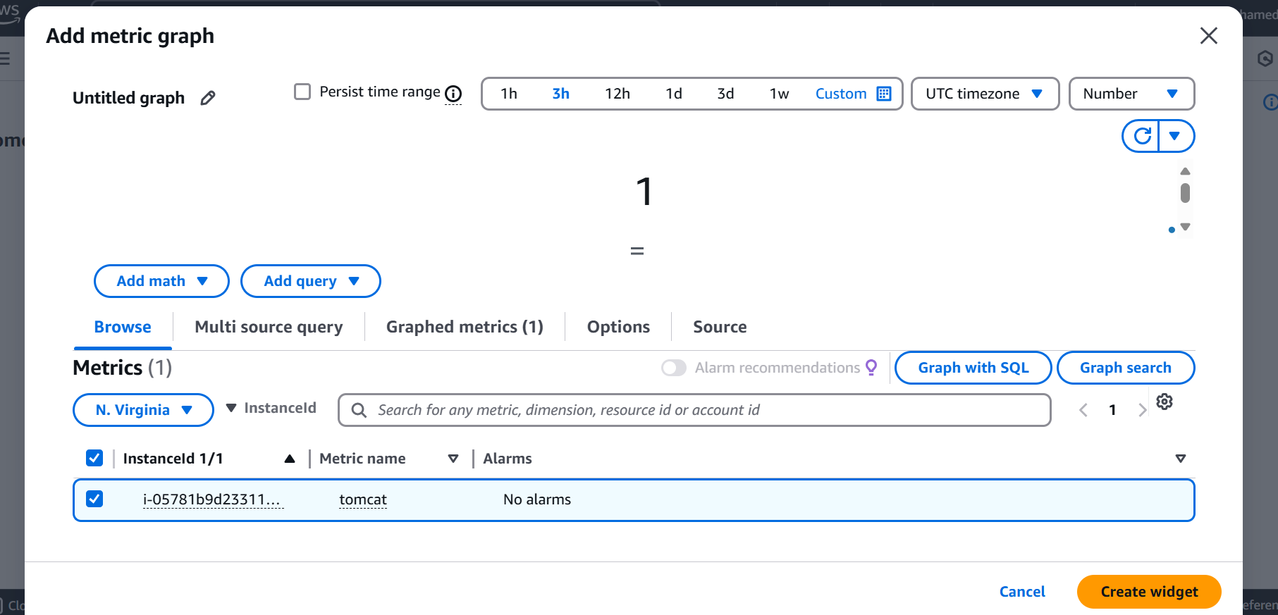

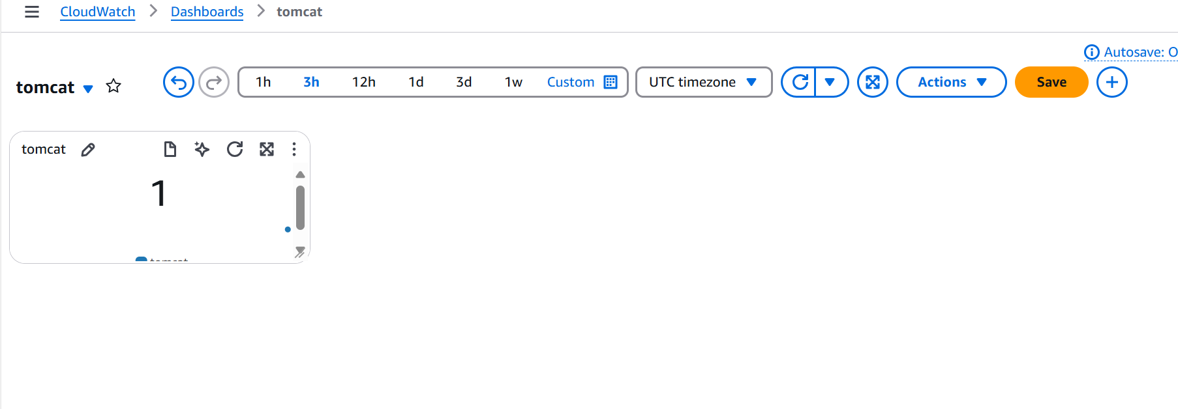

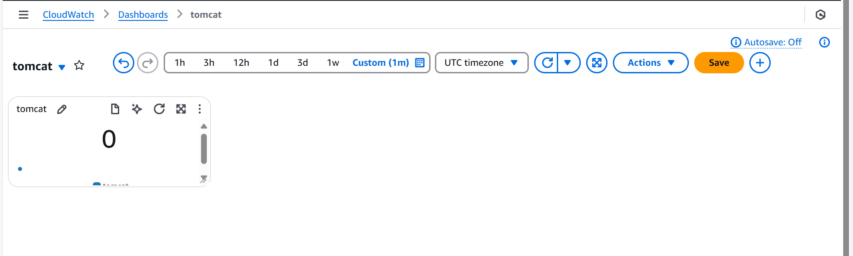

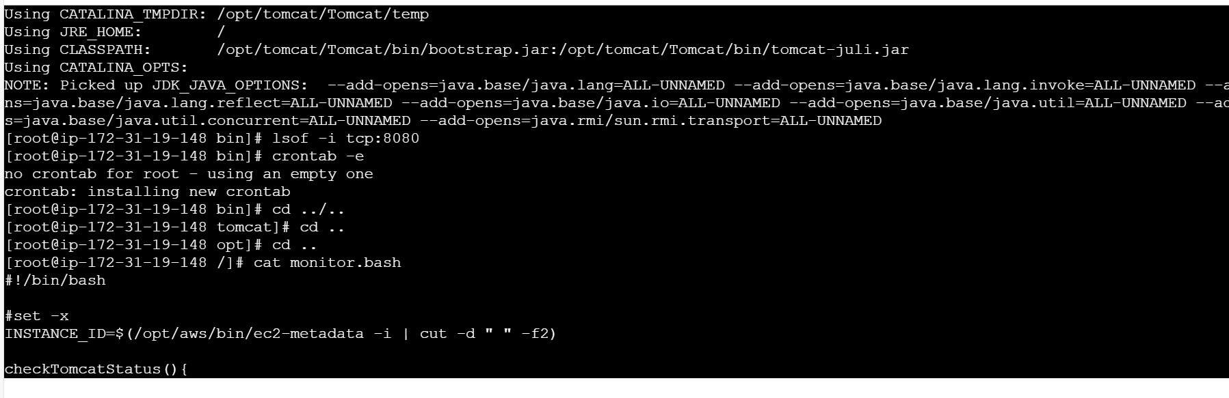

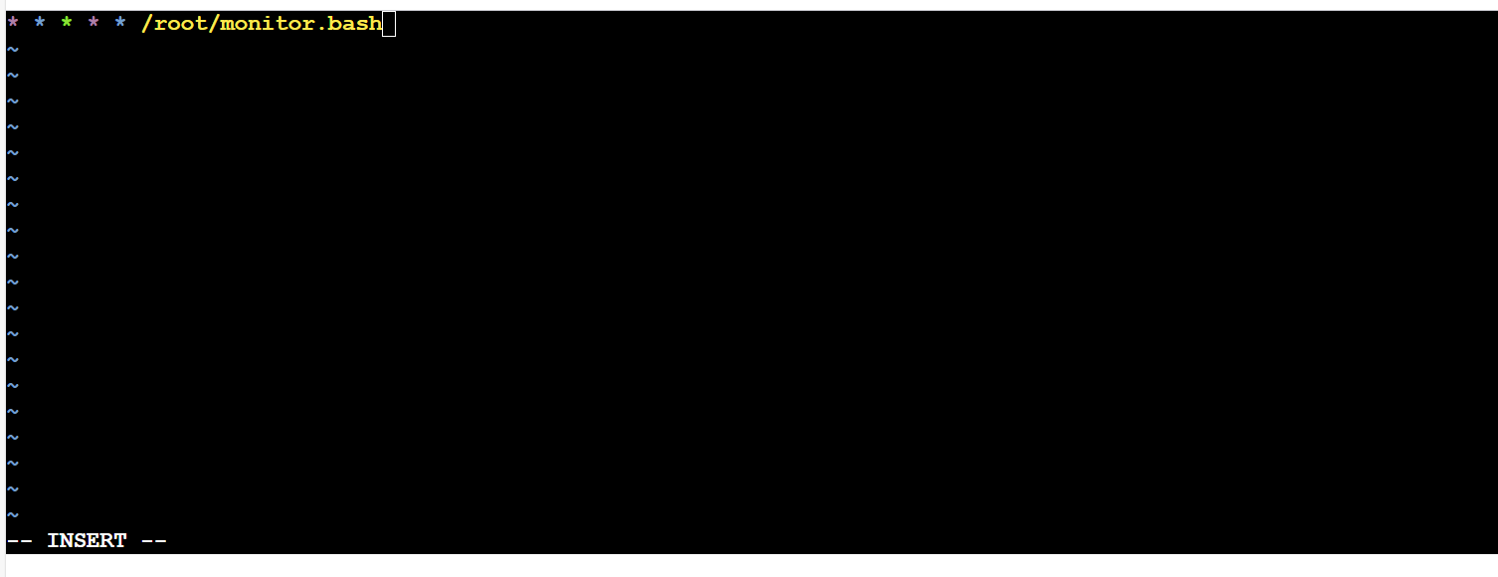

**6) Create Dashboard and monitor nginx service to send the alert if nginx is not running.**

Monitor nginx service and send the meric to Cloudwatch is customizing our own metrics First Go to AWS management console and Install and launch one EC2 Connect the EC2 to console and Switch to root user Now install nginx service using sudo yum install nginx -y once the service is installed successfully, start the service using sudo systemctl start nginx check the service access using Public_Ip:80 of instance.

Next now execute one bash script to push the metrics to Cloudwatch Dashboard for nginx service Execute the bash script file and by changing the permission chmod 777 filename Configure the AWS CLI for aws configure using ACCESS key and secret key credentials Now execute the bash script file to push the metric to cloudwatch dashboard

Check the cloudwatch dashboard for metric Nginx service running Create widget using instance id Configure a cronjob to check for every 1 minute 1 * * * * /root/Nginxmonitoring.bash Create alarms for Nginx metric OK for greater than 0 In alarm for less than 1 In while creating alarms , set SNS for email address alert

So whenever Nginx service is running/stopped alert will be sent to email address and verify in Cloudwatch dashboard.

This is how we can customize our own metrics for Nginx service.

